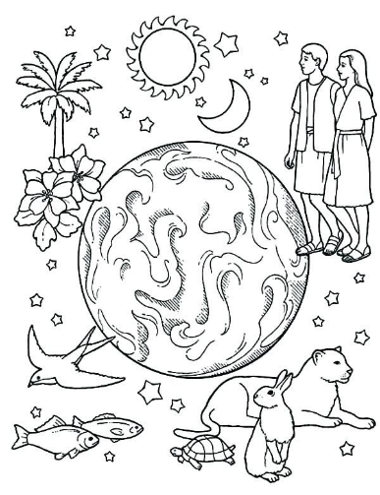
In the Name of the Father, the Son and the Holy Spirit, One God, Amen
Lesson No. ( 2 )
The Creation- God Created the Whole World for Us
References
- Genesis 1
Notes for Servants
- God created us to know Him, live for Him and enjoy being in His presence. However, before He created us, He prepared the whole world to be a sweet home for us.
- We should thank God every minute for all the creations He made for us to serve us. Also, for the power that He gave us to create all these wonderful things to make our life more enjoyable.
Objectives
- General: God's power and His care for us.
- Specific: The children will...
- Learn something about the process of the creation.
- Feel God's love and care through all the good thing that He prepared for us.
- Appreciate all the things they have and the things around them.
Bible Verse "The Lord is my shepherd." Psalm 23:1
Teaching Aids
- Items from nature such as flowers, stones, vegetables, fruits, etc.
- Pictures of some animals and birds.
- Flannel board and figures.
Introduction
- Review last week's lesson.
- Remind the children about the church occasions for the coming week.
- Ask the children how the world would be if there were no people, no houses, no plants, or water.
- Emphasize God's love and care for us through the creation.
Story Time
In the beginning of time there was God but there was no land, no trees, no light. God said, "I want to create a man and call him Adam and I will make him happy. I will love him, and he will love Me and talk to Me all the time. But first, I must prepare the world for him and make everything good for him to live."
On the first day God said, "Let there be light." And there was light. God saw that the light was good, and He separated the light from the darkness. The light God called Day, the darkness He called, Night.
Then, on the second day God said, "Let there be sky in the midst of the waters." God called the sky, Heaven.
Then, on the third day God said, "Let the waters under the heaven be gathered together and let dry land appear." God called the dryland Earth and the waters that were gathered together He called, Seas.
Then, on the forth day God said, "Let there be lights in the sky to divide day from night. Let them be so that they count out the days and months, the seasons and the years." So, there came the sun to light the day and the moon to light the night. Stars appeared also, and God saw that it was good.
On the fifth day God said, "Let there be great living creatures in the waters, and let great numbers of birds fly above the earth." So God created whales and fish and all kinds of living creatures in the waters, and made birds to fly over the waters and the earth.
On the sixth day, God said, "Let there be living creatures upon the earth, cattle and beasts and all kinds of creeping things." And they appeared upon the earth. And He said, "Let man be made in our image to have power over the fish of the sea, the birds of the air, and over everything that moves on the earth." So, man and woman were created in the image of God. He blessed them and said, "You shall have power over all the fish and the birds and over everything on the earth. And every plant and tree on earth you shall have for food. To every bird and every beast and every living creature on earth I give the grass and the plants for food."
Discussion
1 - Follow up the story by talking about it with the children.
2 - Continue the discussion while they do the activity.
Activities

