The Creation Days
"In the beginning God created the heavens and the earth” (Genesis 1:1)
The bible tells us that God created the world in 6 great days or ages.
Read Genesis 1:1-31; 2:1,2 (KJV) and fill in the blanks below to learn the order He used.
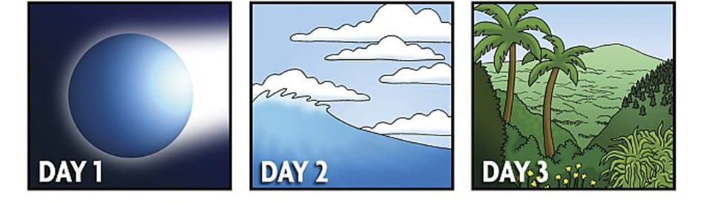
God called the firmament “_____________” (v.8)
God said, " Let the _________ under the heaven be gathered together unto one ________…” (v.9)

God said "Let there be _______” (v.3)

God called the dry land “_________" and the gathering together of the waters He called “________”. (V. 10
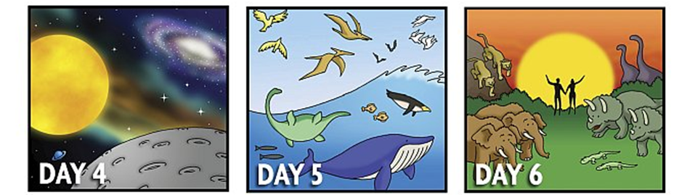
God said, " Let the ______ bring forth the iving _________ after his kind…” (v. 24)
God said, “Let the _______ bring forth abundantly the moving ______ that hath life, and ______ that may fly…” (v. 20)
God said, "Let there be
_______ in the firmament of the heaven to divide the ____ from the _______..." (v. 14)

God said, "Let us make ______ in our _______,” (v. 26)
"God saw everything that He made, and behold, it was “_ _ _ _ _ _ _ _.” (v. 31)
IN THE BEGINNING
Genesis 1:1-31-2:3 KJV
Road Genesis 1:1-31. Starting with Day 1, find the correct path through the maze
to the things that God created on day. Do this until you have matched all the days with the correct pictures„


