+++
In the Name of the Father, The Son, and the Holy Spirit, One God. Amen
+++
Grade Two and Three
POPE KYRILLOS VI: LIFE OF PRAYER
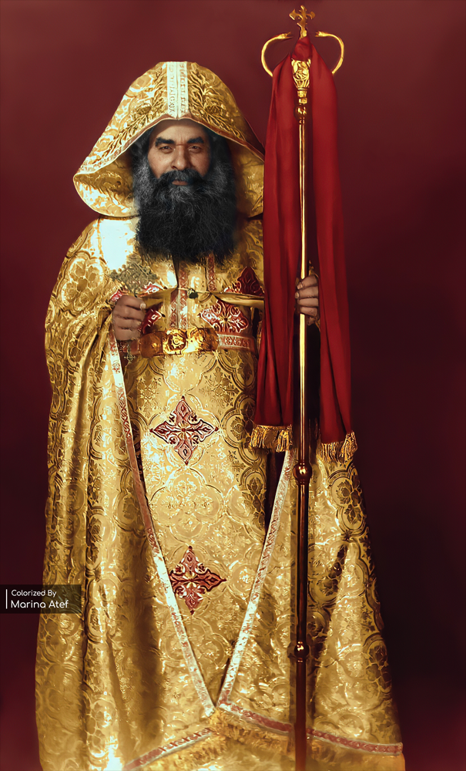
PURPOSE OF THE LESSON:
The children should understand that a life of prayer is important and is good for their spiritual lives.
MEMORY VERSE:
“Seven times a day I praise Thee, because of Thy righteous judgements.” (Psalm 119:164)
LEARNING OBJECTIVES:
- To learn that communication with God is important.
- To learn the importance of prayer and supplication.
- To learn about the church’s role models, whom we call Saints.
- To learn about the intercessions of the Saints.
- To learn about Pope Kyrillos VI and his relationship with God and the Saints, examples being St. Mina, St. Isaac the Syrian, and St. Mary.
LESSON:
Before Pope Kyrillos became a Pope, he was a monk and a priest, his name was Father Mina. He spent many years in the monastery and then alone in the desert. He would read the bible, pray, and read spiritual books, especially he would read the writings of St. Isaac of Nineveh/Syria. He loved spending time with God, talking to Him, learning about Him, and growing in His love.
After his time in the desert, he moved into a deserted windmill, which he turned into a church. In this small church he prayed liturgies daily and raised evening incense. He accepted everyone who came to him, asking for their prayers, especially the children.
Fr. Mina had a special relationship with St. Mina, so anytime a child came to him, he used to say, “I will send St. Mina to help you.”
After Fr. Mina was selected as a Pope and changed his name to Pope Kyrillos, he continued to pray daily liturgies very early in the morning. He loved the children and allowed them to serve with him inside the sanctuary. The children also loved him, and in turn, started learning the prayers and the Coptic praises. He also encouraged the Sunday school movement, which helped educate the multitudes and the children about God.
Since Pope Kyrillos was a man of prayer, many miracles occurred during his time as Patriarch (Pope). One day, a child and his brother were returning home, on a bike, after liturgy, when suddenly a car hit them. Back at the church, Pope Kyrillos stepped out of his room and said with a loud voice, “God forbid; St. Mina protect your sons.” St. Mina quickly went and grabbed the boys, saving their lives.
One time, the Pope fell asleep while sitting in the Church to greet the students because he was sick. One young man came and suddenly started screaming and yelling because he was possessed by the devil. Pope Kyrillos quickly woke up and prayed and as quickly as the possessed young man started screaming, he was healed. The Pope Kyrillos went back to sleep.
Not only did the Pope have a special relationship with St. Mina, and St. Isaac the Syrian, but he also had a relationship with St. Mary. He used to use her intercessions to heal the sick and help people in times of trouble. St. Mary also appeared on top of the Church of Zaitoun during his papacy, which was one of the greatest and longest spiritual sights of modern-day time.
A life of prayer is very important for us because it is the way in which we communicate with God and get to know Him more. With the power of prayer, amazing things happen in our lives. Pope Kyrillos used to say that “Prayer is everything! Prayer can do all things, for it moves the Hand that manages the whole universe.”
“Trust that God sees you. He hears you and feels you. So, your little matters are very big before His love and your big matters are very small before His might.” – Pope Kyrillos VI.
QUESTIONS:
- Ask the children who their favourite Saint is?
- Ask the children if they ever pray for someone else?
- Ask the children if they can think of examples in the bible of people praying to God? (Jonah in the belly of the great fish, Jesus in the garden of gethsemane, etc.)
- What are ways you can pray? (Thanksgiving prayers, praising, asking God for help and forgiveness, etc.)
- Why do you think prayer is important?

