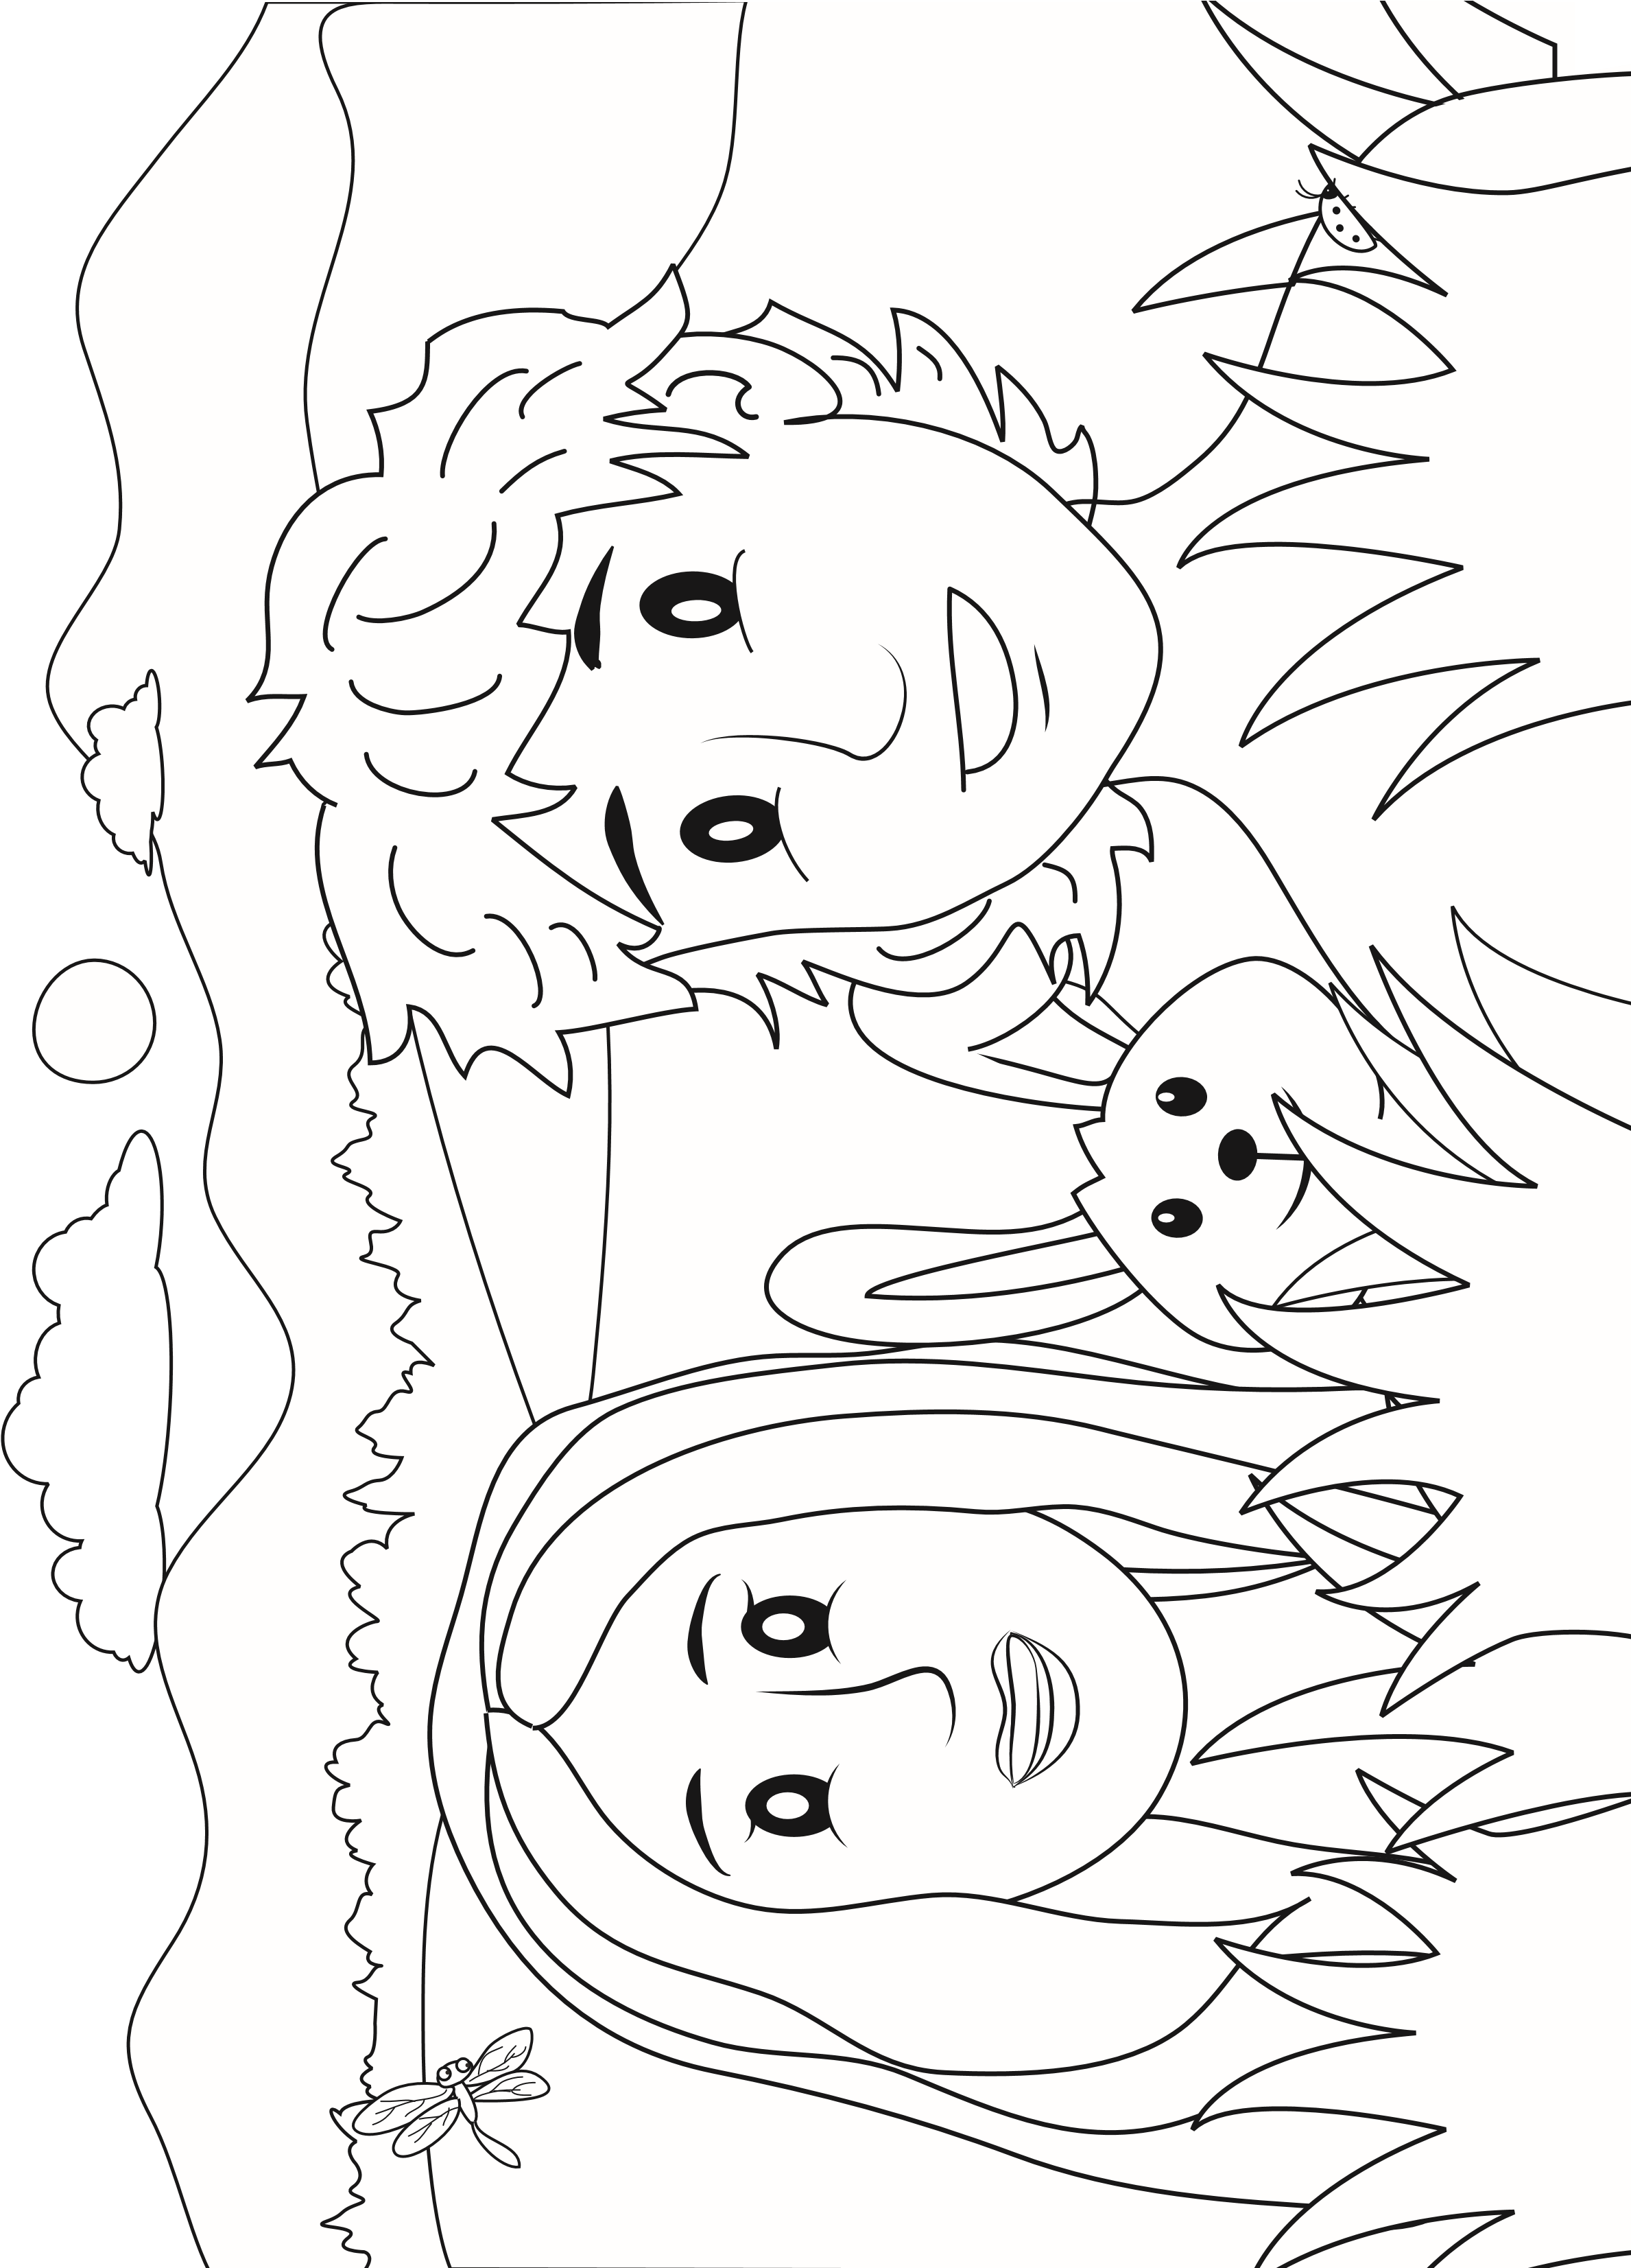
My Name is ______________________________________
Adam and Eve Sunday School Worksheets
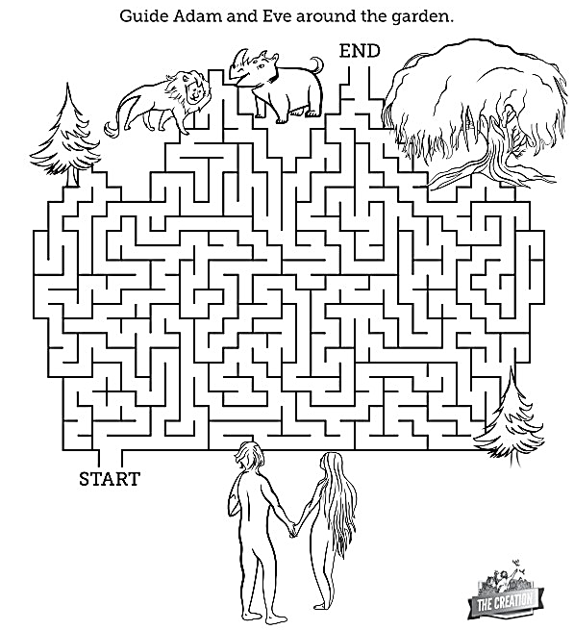
Garden Maze

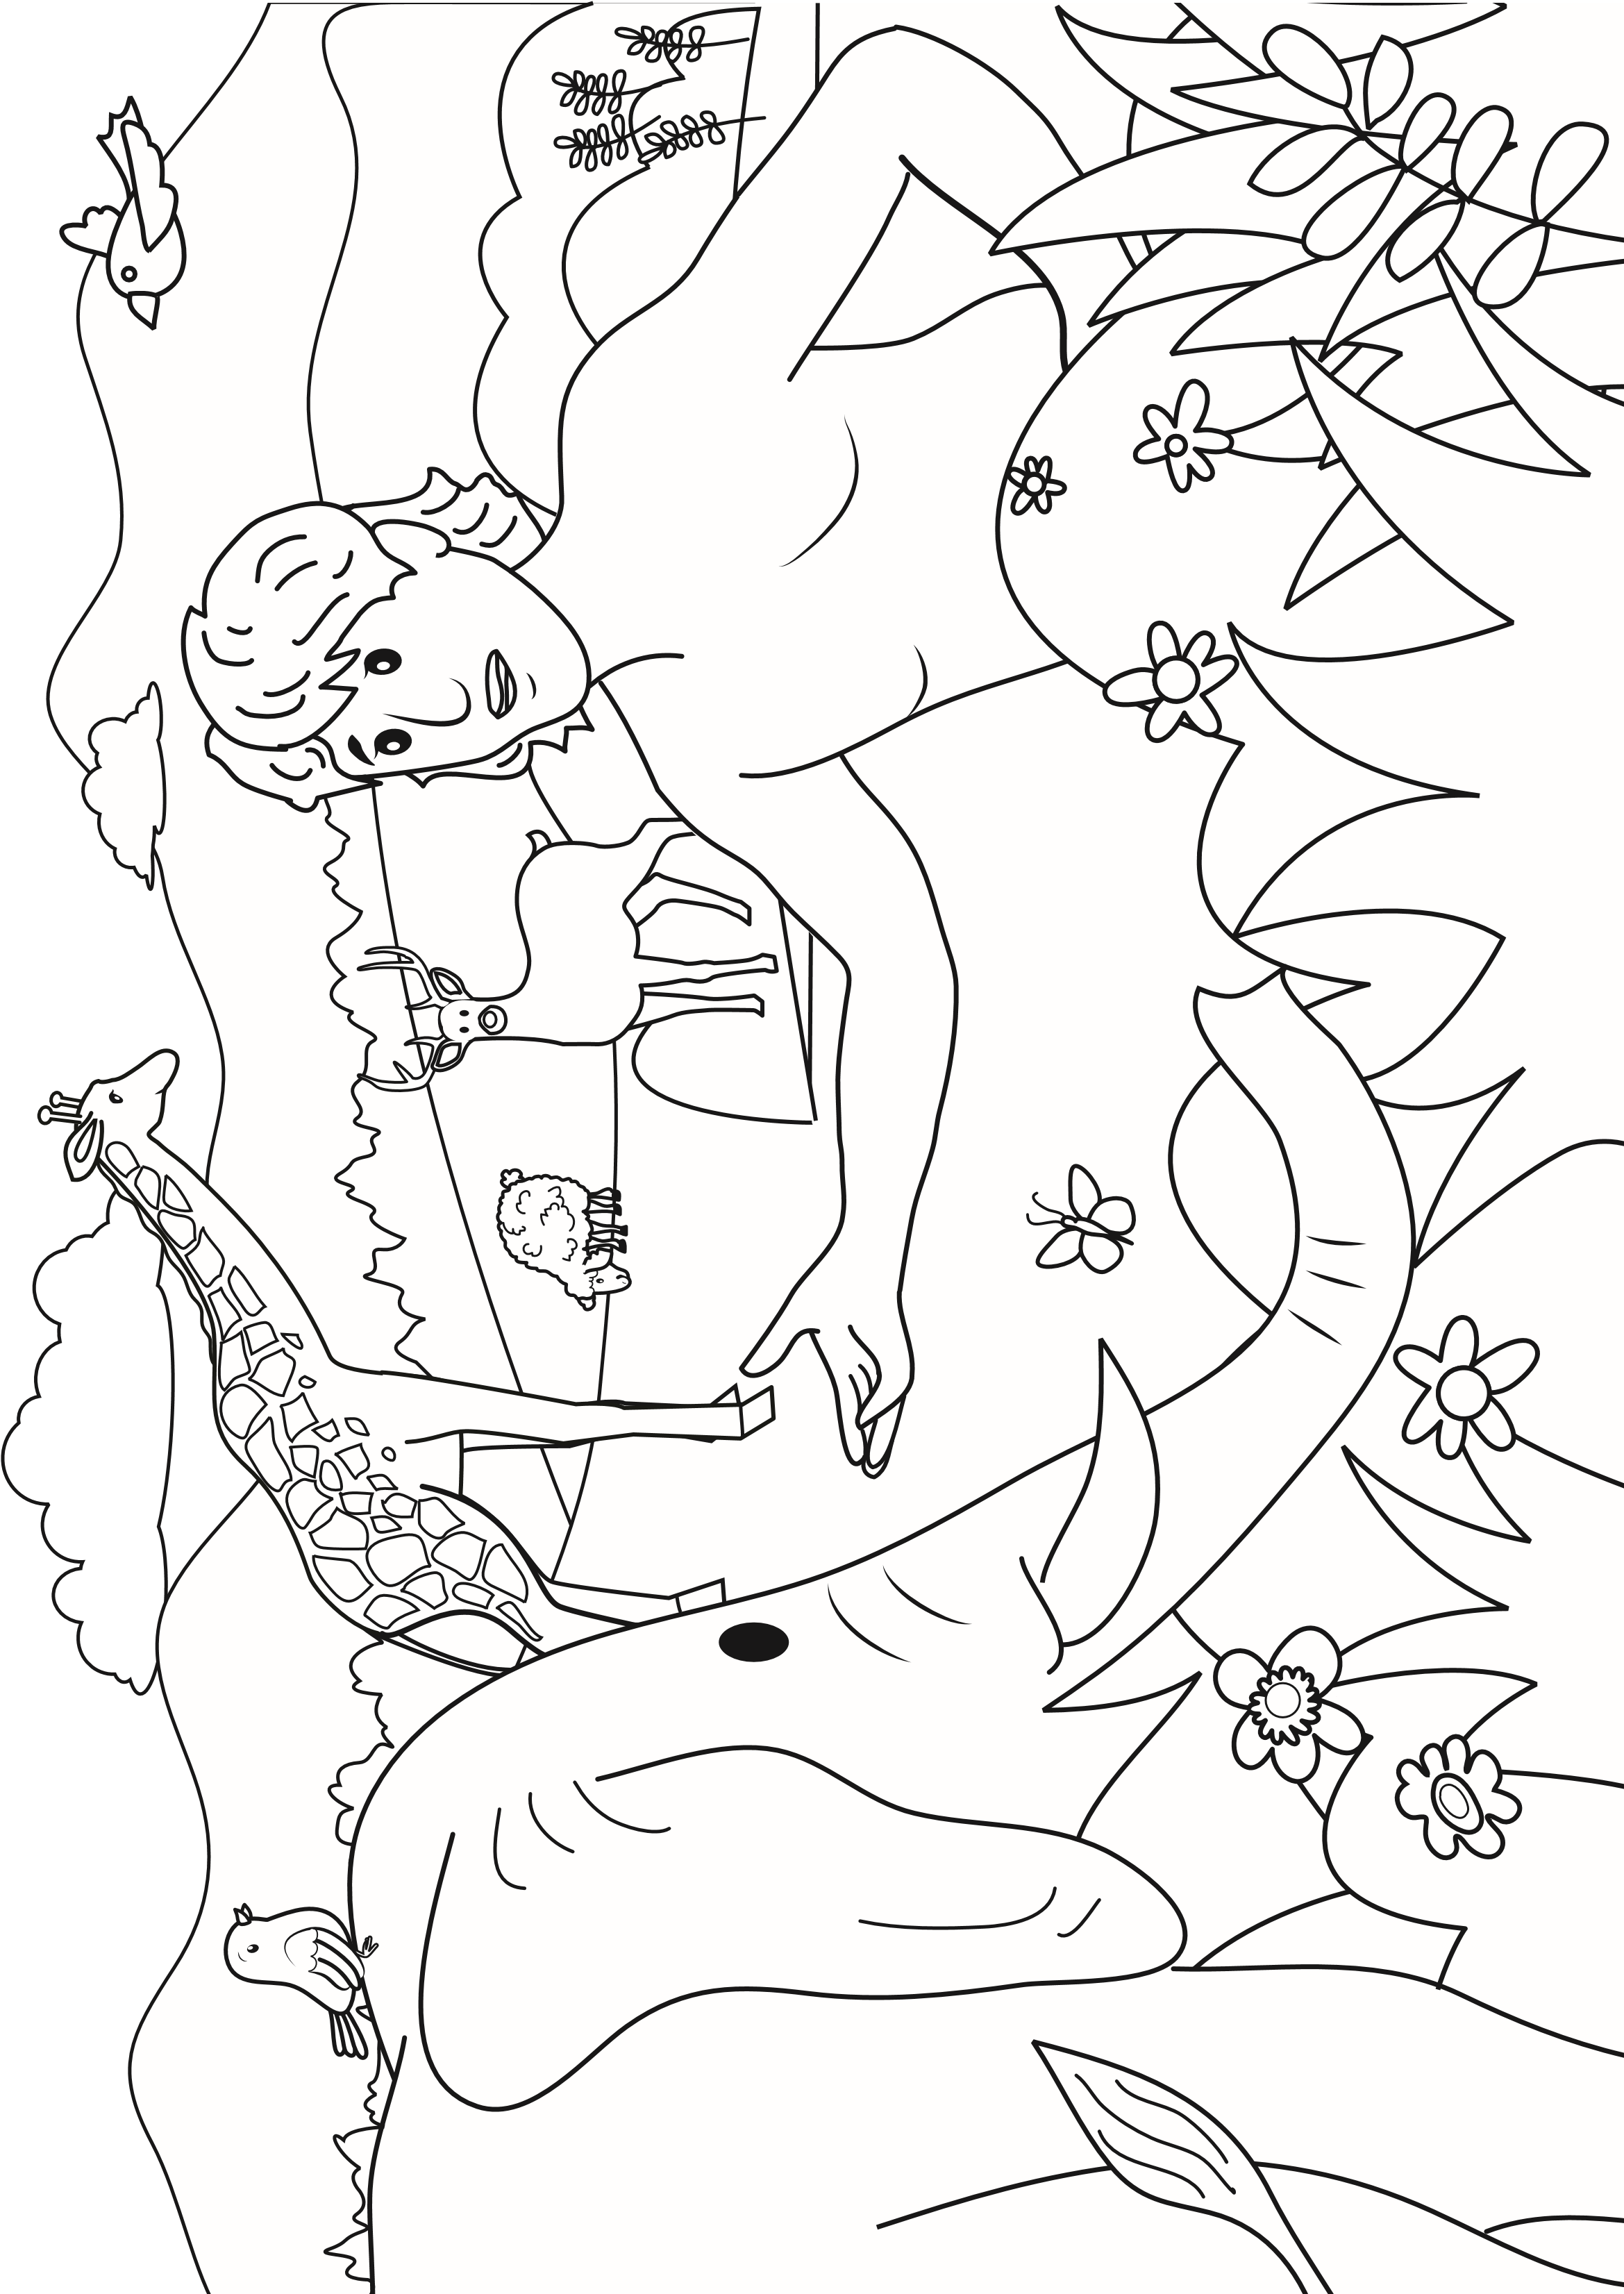
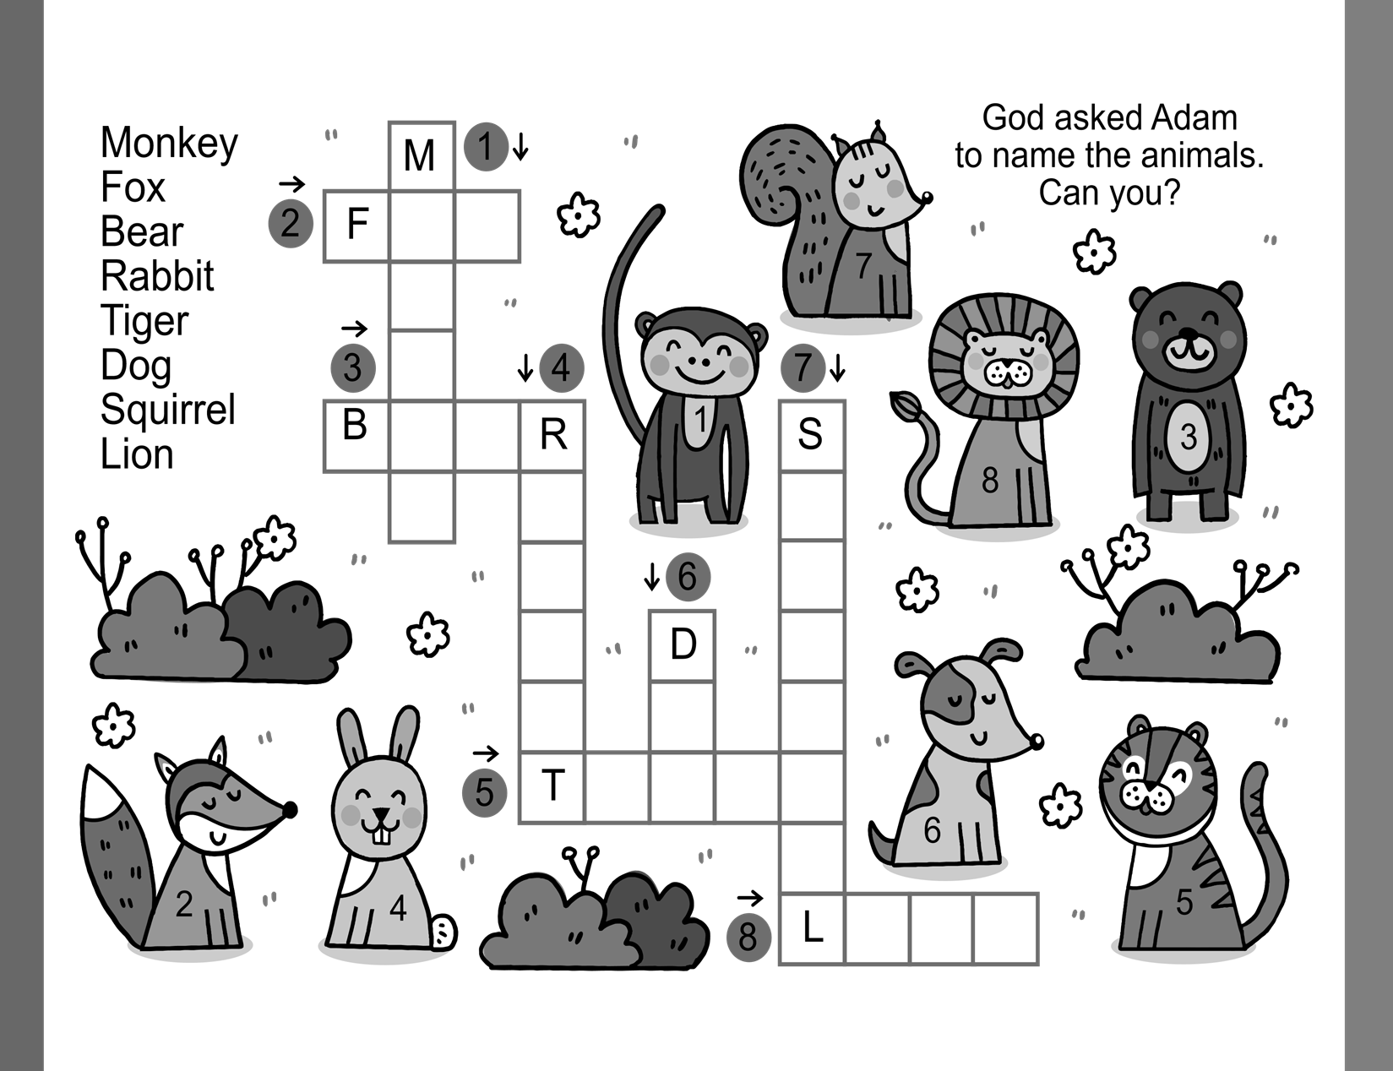

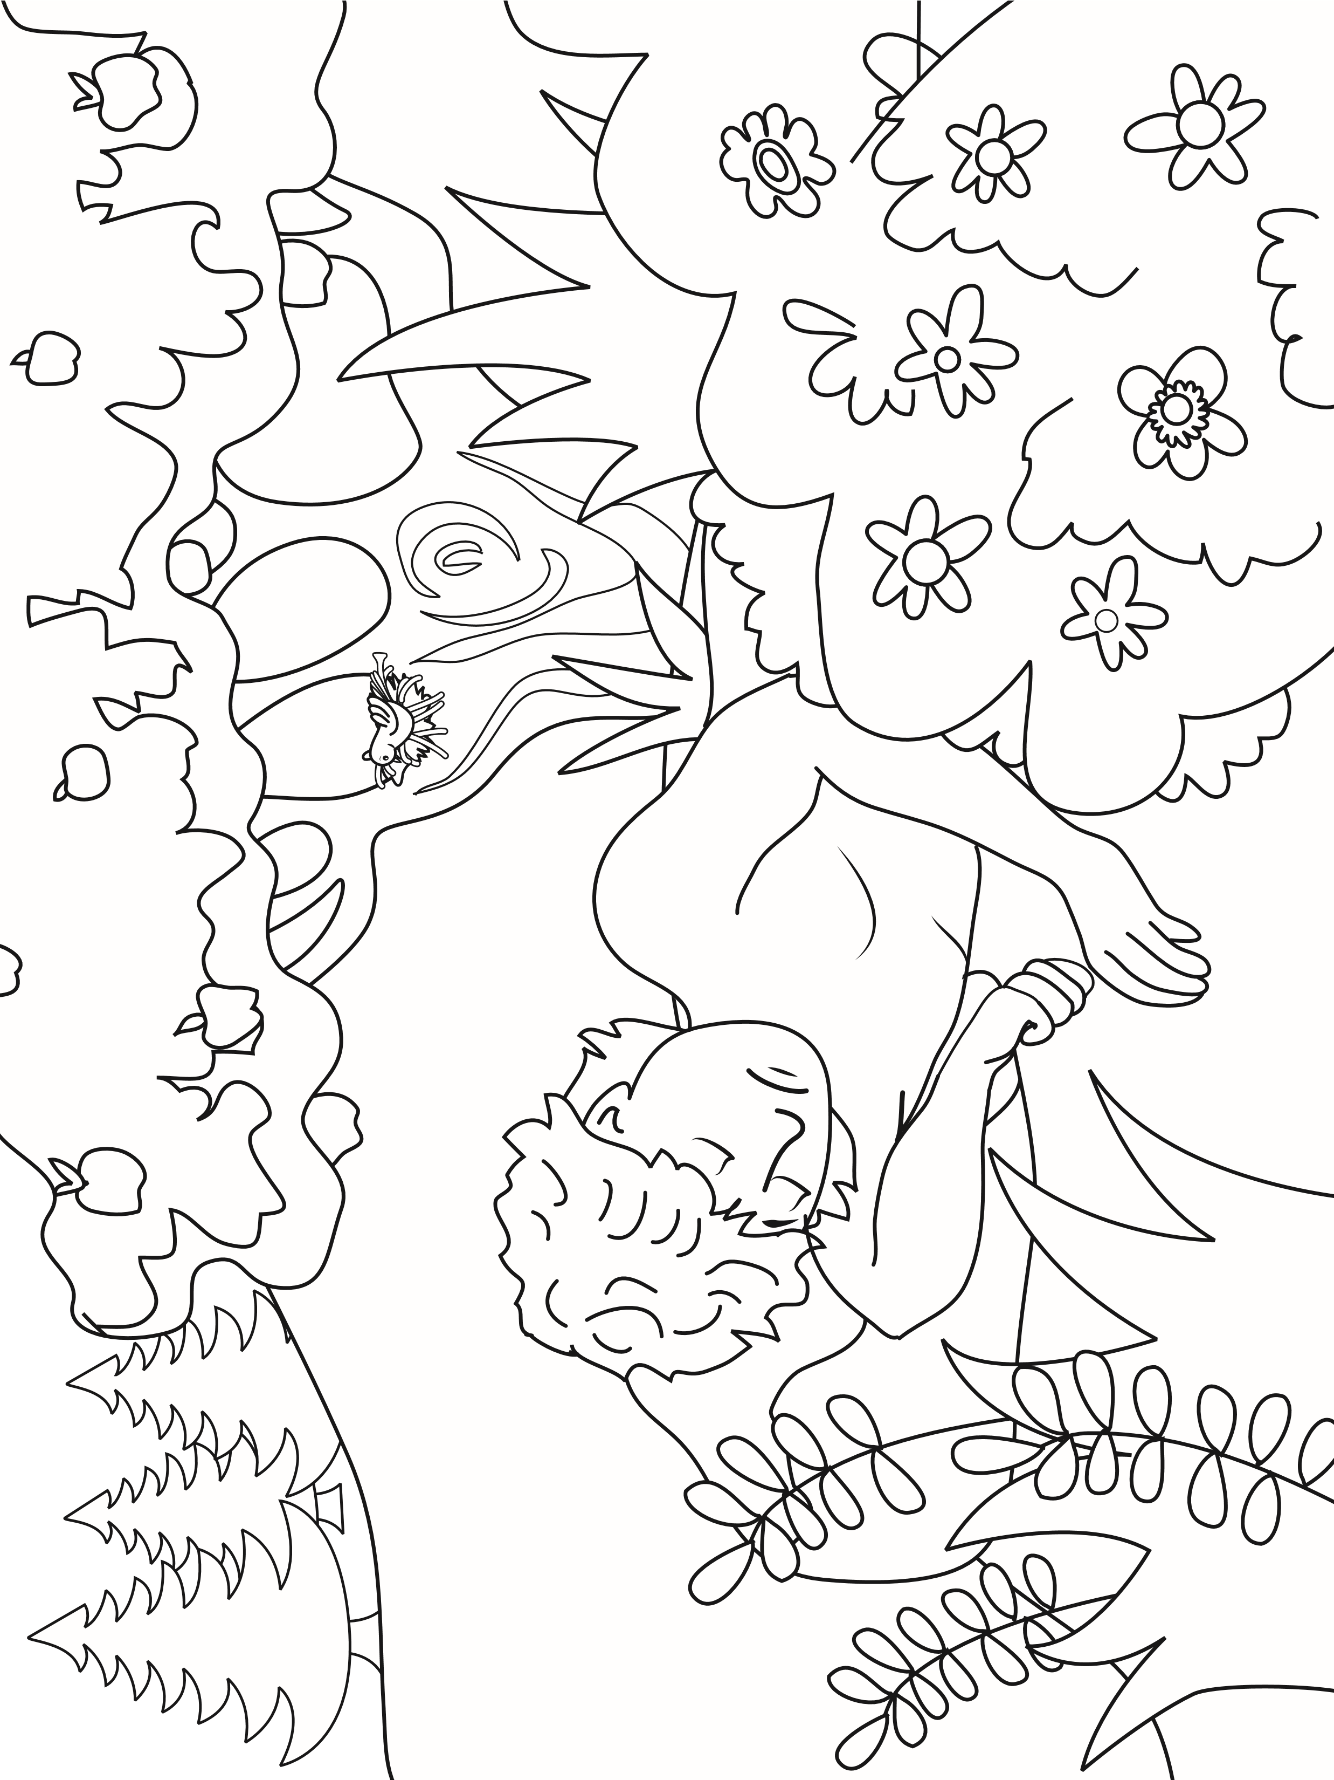

Today’s Lesson was about? ____________________________________________________________________________________________________________________________________________________________________________________________________________________________________________________________________________________________________________________________________
Today’s Verse is: ____________________________________________________________________________________________________________________________________________________________________________________________________________________________________________________________________________________________________________________________________
What Did You Learn Today?

