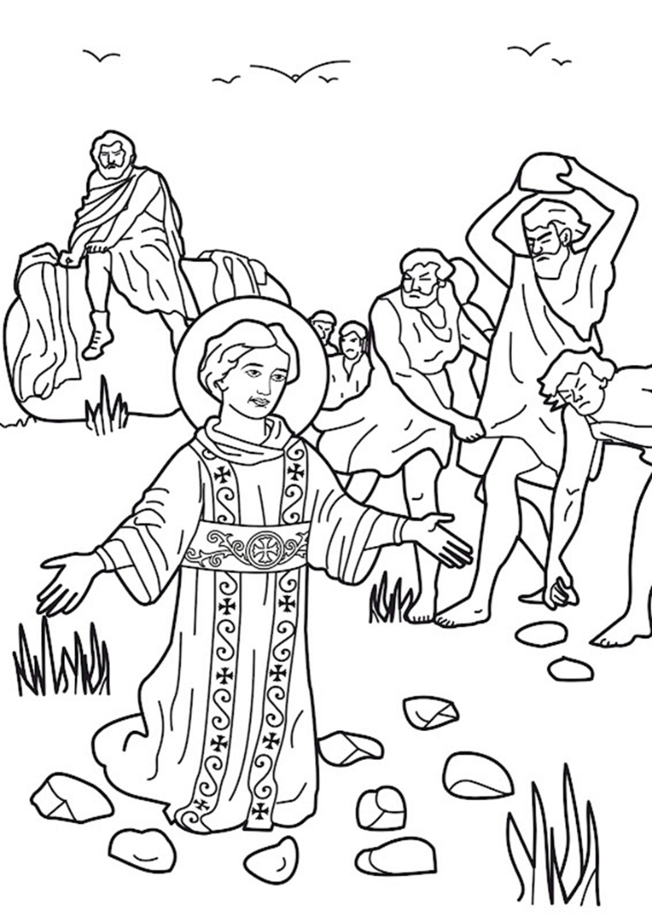
Grade One and Two Sunday School Activity Booklet
2021-2022
MASTER COPY
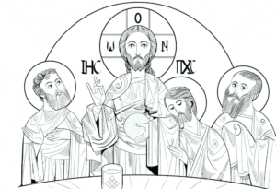
Hymn – Thou Crownest the Year with Thy Goodness

Refrain: +++
Thou crownest the year with Thy goodness,
And Thy paths drip with fatness-
Our hearts overflow with gladness,
And our lips rejoice with thankfulness!
+++

+++
Come, ye thankful people, come:
Raise the song of harvest-home!
All be safely gathered in,
Before the winter storms begin.
God, our Maker, does provide
for our wants to be supplied-
Come to God's own temple, come:
Raise the song of harvest-home!
+++
All this world is God's own field,
Fruit unto His praise to yield-
Wheat and tares together sown,
Unto joy or sorrow grown.
First the blade and then the ear,
Then the full corn shall appear-
Lord of harvest, grant that we
Wholesome grain and pure may be.
+++
For the Lord our God shall come,
And shall take His harvest home
From His field shall purge away
All that does offend today:
Give His angels charge, at last,
In the fire the tares to cast-
But the fruitful wheat to store
In His barn for evermore.
+++
Then, thou Church triumphant, come:
Raise the song of harvest-home!
All be safely gathered in,
Free from sorrow, free from sin
There forever purified,
In God's garner to abide:
Come, ten thousand angels, come:
Raise the glorious harvest-home!

HYMN: MY CROSS
Arabic Salibi ya salibi

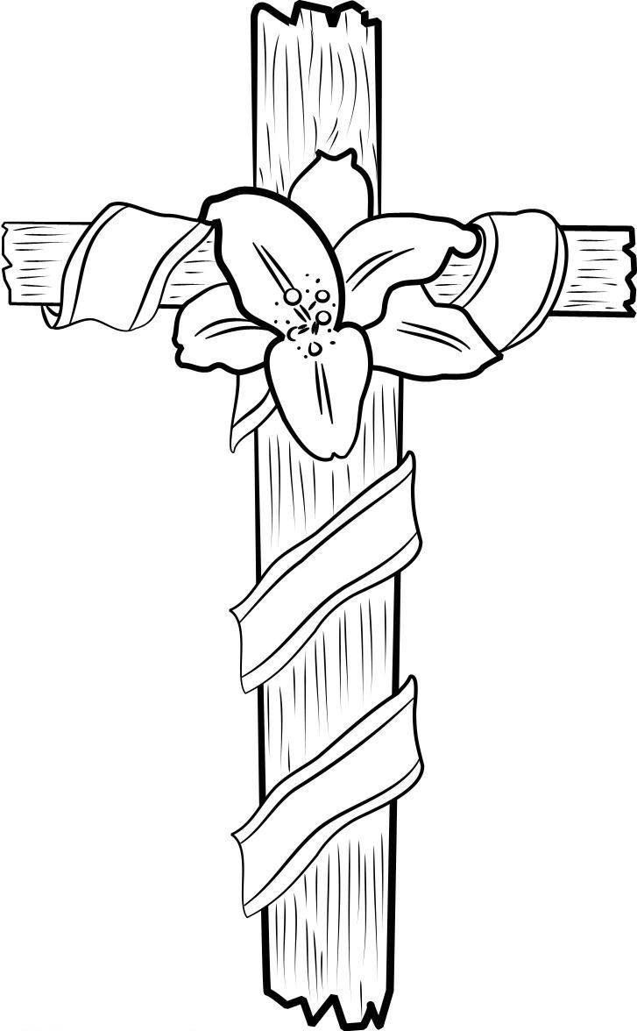
My cross, my cross,
My glory is in you!
I place you on my bosom,
And in my bedroom too.

Refrain:
My cross, my cross,
You're made of lowly wood,
But in my heart, my cross,
You're more precious than gold.
+++

My cross, my cross
Is with me everywhere:
I sign you every morning.
And whenever I fear.

My cross, my cross,
My victory's in you!
The pledge of my success
In whatever I do.

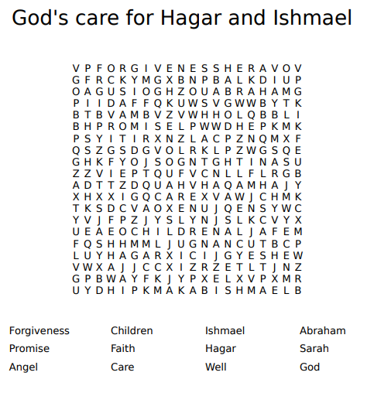
Verse of the week:
“Have faith in God.”
(Mark 11:22)

The Three Visitors: The Lord visits Abraham
“Be not forgetful to entertain strangers.”
Hebrews 13:2 KJV
One day, when it was summer and very hot at noon, Abraham was sitting at the entrance of the tent in the shadow of a big tree.
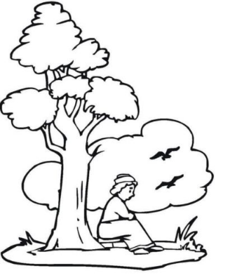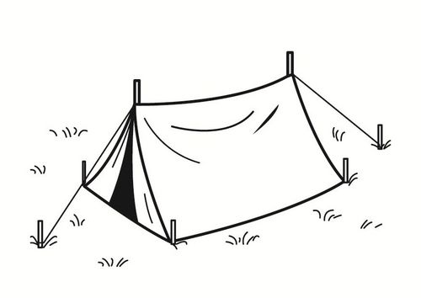
Three men were passing by his tent. Abraham ran towards them to meet them. He thought of entertaining those strangers as the Scripture says:
STRANGERS
"Be not forgetful to entertain _ _ _ _ _ _ _ _ _." (Hebrews 13:2)
He went towards them and bowed before them as a sign of respect and greeting as the custom was in those days. He invited them saying: "Honour me by having dinner with me."

The three men accepted his invitation. They sat under the tree, in its shadow, waiting for the dinner. Abraham brought water and a towel for them, and he washed the guests' feet.
THREE
- How many men were there? _______________________

Abraham entered his tent and asked Sarah his wife to hurry and bake some bread, then he ran to the herd and picked out a calf that was tender and fat and gave it to a servant who hurried to cook it for dinner. He took some cream, some milk, and the meat, and set the food before the men. The men prayed before they ate. There under the tree he served them himself as they ate. Then they said: "Thanks Abraham for your hospitality."

When the men finished their food and about to leave, they told him that by this time next year Sarah would have a son. When Sarah heard this, she _ _ _ _ _ _ _ (Gen.18:12) to herself because she thought she was too old to have a baby.
LAUGHED
ANYTHING
HARD
Now the LORD knew her thoughts and said "Is _ _ _ _ _ _ _ _ too _ _ _ _ for the LORD?" (Gen. 18:14)
Unscramble the Letters below to fill in the answers above:
GRSSTNAER EERHT GULDAHE TAYNGIHN RADH SSUEJ SLEGNA
BONUS:
Who were the three men?
ANGELS
JESUS
_ _ _ _ _ and two _ _ _ _ _ _
God Chooses a Wife for Isaac
Can you help Abraham’s servant find a wife for Isaac?

"Seek and you will find."
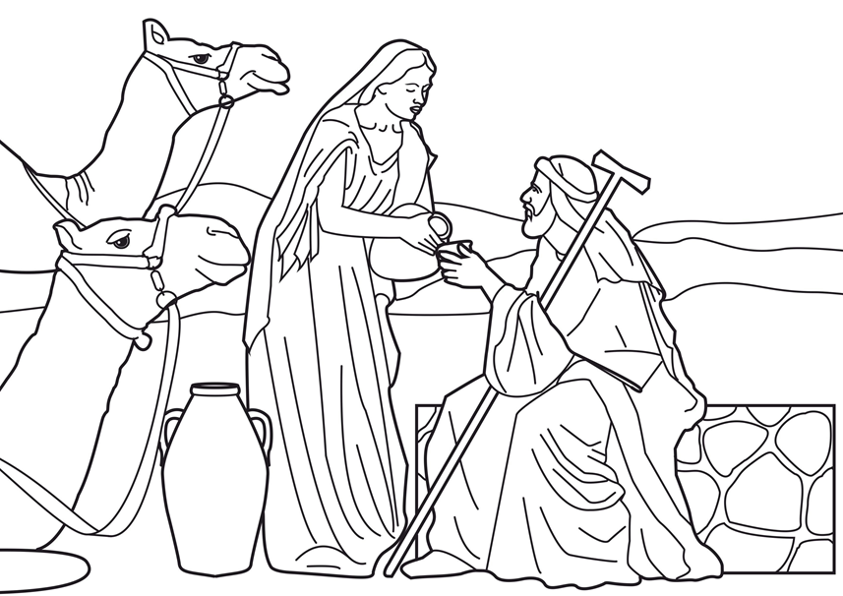

(Luke 11:9)
End here
Start Here

God’s Care for the Child Moses
"Casting all your care upon Him."
1 Peter 5:7
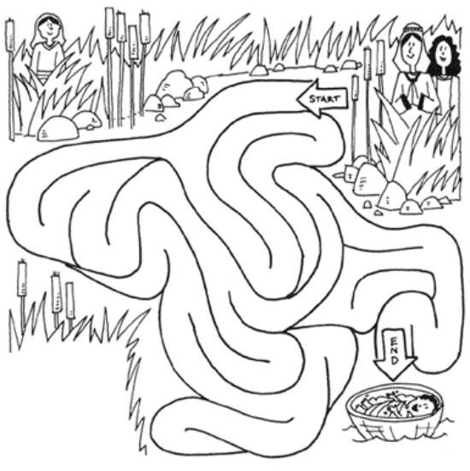

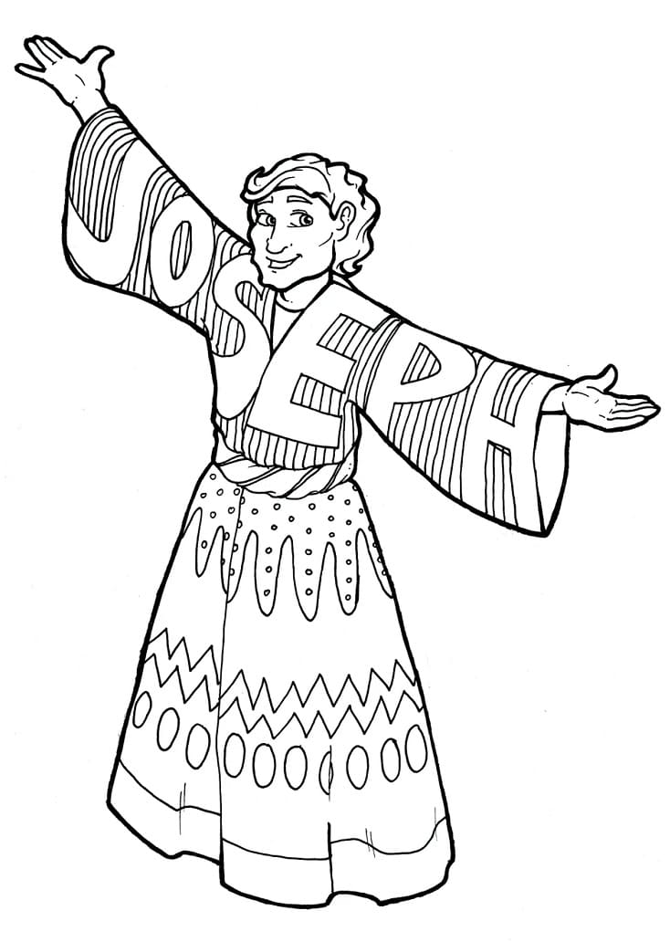
Joseph Part One
Joseph King of Dreams
“A faithful man shall abound with blessings” (Prov 28:20)
True or False - Circle the correct answer
- Joseph had fourteen brothers
TRUE OR FALSE
- Joseph’s mother was named Rachel
TRUE OR FALSE
- Joseph’s father was named Abraham
TRUE OR FALSE
- Joseph’s brothers loved Joseph very much
TRUE OR FALSE
- Joseph was the youngest out of his brothers
TRUE OR FALSE
- Joseph was sold into slavery by his brothers
TRUE OR FALSE
- Joseph’s father thought that Joseph was dead
TRUE OR FALSE
- Joseph’s father favoured him above all his other sons
TRUE OR FALSE
- Joseph had an easy life in the first few years when he was living in Egypt
TRUE OR FALSE
- Joseph’s father fashioned a coat of one single colour and gifted it to Joseph
TRUE OR FALSE
Joseph Part Two
Joseph's Family Reunion
Genesis 39-41 (KJV)
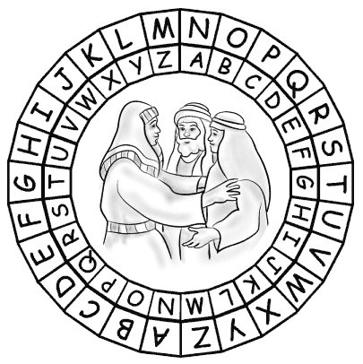
To find out what Joseph said to his brothers, when he revealed himself to them, use the code to solve the puzzle. Find the Letter in the message on the outside circle. Match it with the letter under it on the inside circle.
"I am Joseph your brother, whom ye sold into Egypt. . . “
GOD DID SEND ME BEFORE
____________________________________________________
TBQ QVQ FRAQ ZR ORSBER
YOU TO PRESERVE LIFE
____________________________________________________
LBH GB CERFREIR YVSR
(Genesis 45:4-5 KJV)
THE SONS OF JACOB
(GENESIS 29:31-30:24; 35:16-26)
G B K V L H A M C T I H N T A
S O S J N J I S S A C H A R A
N N P N O U V Q J N T F H T U
B H O S A Q L S W D R E H S A
K S E E V P C U Y R A V I D E
K P P R M I H Q B A L N U D N
H S R G D I A T J E B I A Q Q
O R N H A L S V A Z Z M F P N
J R O A D D L P T L Z A F U N
Q V E D Z H O B N E I J T J A
S N S U Z T Z Q A M Z N Q K Y
P G L J B Y M J S D N E H S Q
M D K W N E F I L W K B A M U
L E V I O A N C P Q O I U J Q
B P W E W O D T U X B O U T T
ASHER ISSACHAR NAPHTALI
BENJAMIN JOSEPH REUBEN
DAN JUDAH SIMEON
GAD LEVI ZEBULUN
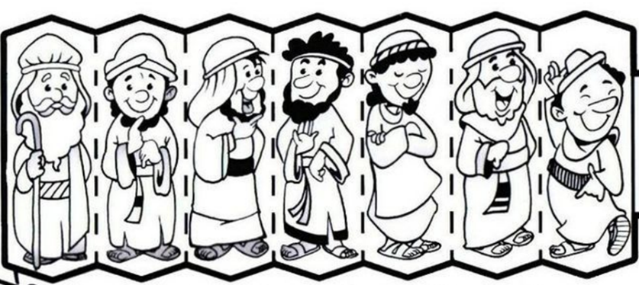
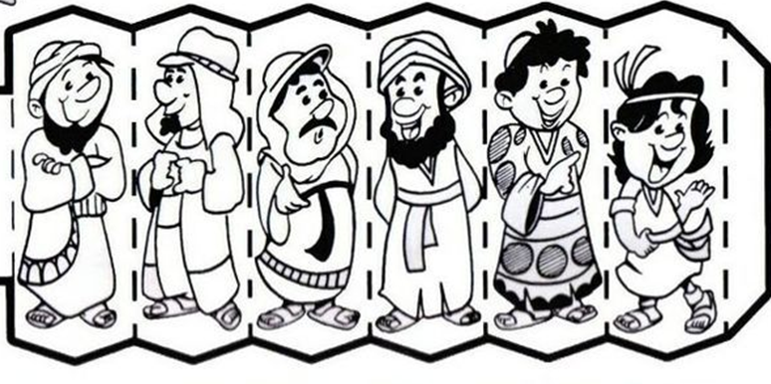


“Bless the Lord O my soul.” Psalm 103:2
Refrain:
Bless the Lord oh my soul
Oh my soul
Worship His Holy name
Sing like never before
Oh my soul
I’ll worship Your Holy name

+++

The sun comes up
It’s a new day dawning
It’s time to sing Your song again
Whatever may pass
And whatever lies before me
Let me be singing
When the evening comes

+++

You’re rich in love
And You’re slow to anger
Your name is great
And Your heart is kind
For all Your goodness
I will keep on singing
Ten thousand reasons
For my heart to find

+++

And on that day
When my strength is failing
The end draws near
And my time has come
Still my soul will
Sing Your praise unending
Ten thousand years
And then forevermore
Forevermore

+++

Bless the Lord oh my soul
Oh my soul
Worship His Holy name
Sing like never before
Oh my soul
I’ll worship Your Holy name
Yes I’ll worship Your Holy name
I’ll worship Your Holy name
Sing like never before
Oh my soul
I’ll worship Your Holy name
Jesus I will worship Your Holy name
Worship Your Holy name

God Sends a Raven to Elijah
“Bless the Lord O my soul. ”
Psalm 103:2
Handprint Raven Craft
Please ask your parent to help out with this activity.

Materials:
- paper (for handprints) - black construction paper works well
- pencil or marker
- scissors
- glue
- something to color with
Craft Instructions:
- Template is provided on the next two pages
- Ask an adult to help cut out the template pieces
- Parents please trace the child's hands on another piece of paper and cut out (two handprints) -- black construction paper works well (or you can color a piece of white paper)
- Glue the raven together
- Glue the head (circle) to the body (upside down teardrop shape)
- Glue the face onto the head
- Glue the tuft of feathers to the top of the head
- Glue the tail to the back of the body
- Glue the feet onto the bottom of the body
- Glue the handprint wings on the back of the body
- Glue the flower on a wing or beside the neck
- Have the child colour the raven

Elisha and the Jars of Oil (KJV)
“Bless the Lord O my soul.” Psalm 103:2
E
L
L
V S S E S
O
I
L
S

A
Y
E
D
E P T Y
P U R E D
B
O
N
D
M
E
N
1
2
3
4
5
6
7

1 Down | "Now there cried a certain woman of the wives of the sons of the prophets unto Elisha, saying, Thy servant my husband is dead; and thou knowest that thy servant did fear the LORD: and the creditor is come to take unto him my two sons to be ___." (2 Kings 4:1)
5 Down | "And Elisha said unto her, What shall I do for thee? tell me, what hast thou in the house? And she said, Thine handmaid hath not any thing in the house, save a pot of ___." (2 Kings 4:2)
4 Across | "Then he said, Go, borrow thee vessels abroad of all thy neighbours, even ____ vessels; borrow not a few." (2 Kings 4:3)
6 Across | "And when thou art come in, thou shalt shut the door upon thee and upon thy sons, and shalt pour out into all those ___, and thou shalt set aside that which is full." (2 Kings 4:4)
2 Across | "So she went from him, and shut the door upon her and upon her sons, who brought the vessels to her; and she ___ out."(2 Kings 4:5)
3 Down | "And it came to pass, when the vessels were full, that she said unto her son, Bring me yet a vessel. And he said unto her, There is not a vessel more. And the oil ___." (2 Kings 4:6)
7 Down | "Then she came and told the man of God. And he said, Go, ___ the oil, and pay thy debt, and live thou and thy children of the rest."(2 Kings 4:7)

God Cares for Esther
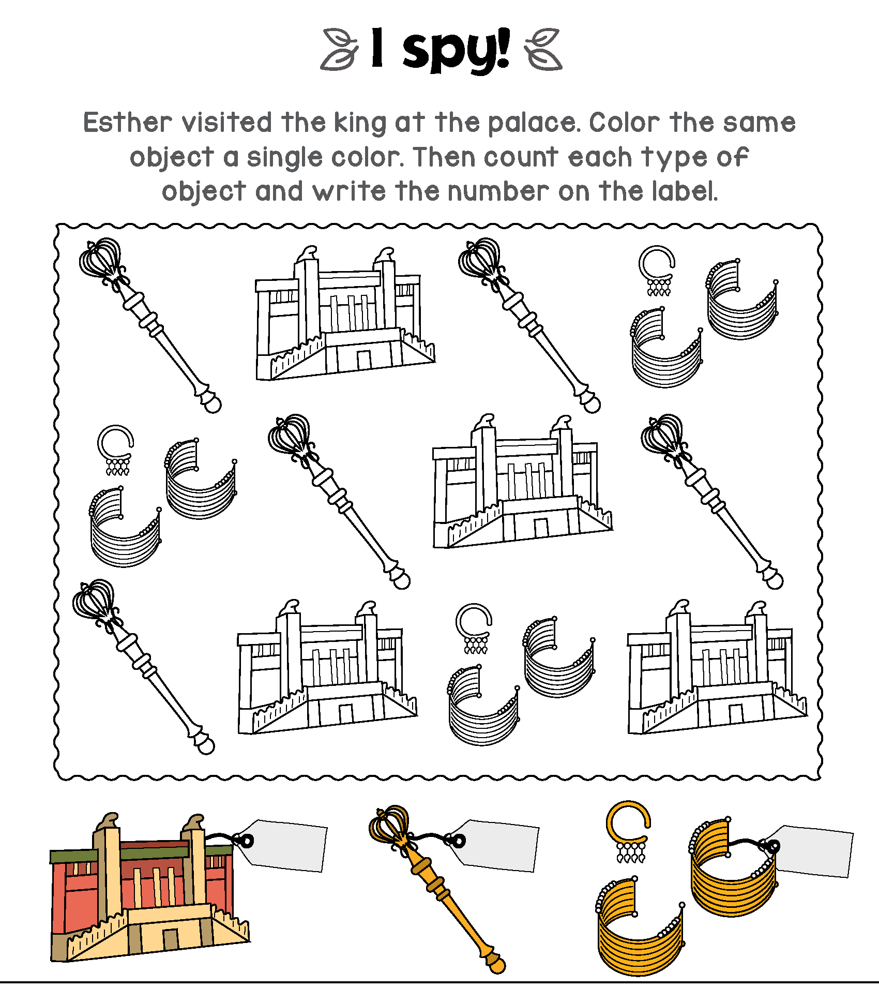
“Bless the Lord O my soul.”
4
3
5
(Psalm 103:2)

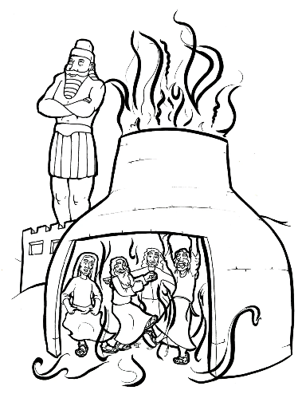
Gods Care for the Three Friends in the Blazing Furnace
Hymnology:
God, my God is the One,
Who saved you from the fire,
O Sedrach, Misach and Abednego:
Hos Erof ariho-oo chasf.
(English: Praise Him and Exalt Him above all)

Unscramble the letters to find the words in our Shadrach, Meshach and Abednego Anagram
Word List:
- angel, bowed, fourth, furnace, miracle, Nebuchadnezzar, trust, statue, unharmed, worship

STATUE

aesttu _____________________________________________________________
NEBUCHADNEZZAR
aabckeehnnruzz_____________________________________________________
WORSHIP
hioprsw ____________________________________________________________
FURNACE
acefnru ____________________________________________________________
FOURTH
fhortu_____________________________________________________________
UNHARMED
adehmnru__________________________________________________________
BOWED
bdeow_____________________________________________________________
TRUST
rsttu_______________________________________________________________
MIRACLE
aceilmr_____________________________________________________________
ANGEL
genal______________________________________________________________
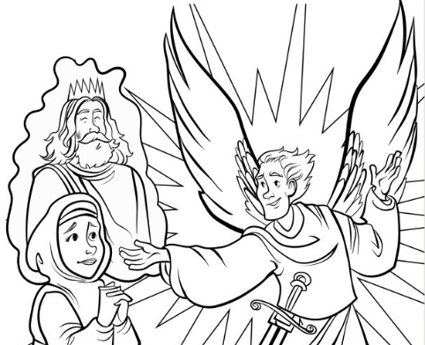
God Cares for Zechariah and Elizabeth
"Prepare ye the way of the Lord."
Luke 3:4
N | M | L | N | N | G | L | U | N | A | M | M
O | S | U | A | P | M | N | P | I | E | A | H
I | L | M | T | R | B | G | L | R | R | A | Y
S | E | H | T | E | B | A | Z | I | L | E | M
I | I | R | L | P | K | B | F | G | E | T | M
V | D | I | S | A | I | R | A | H | C | A | Z
S | E | I | E | R | B | I | E | T | Y | W | E
F | S | P | I | E | A | E | E | E | R | T | C
R | S | T | E | M | P | L | E | O | A | B | J
T | E | L | B | A | T | E | T | U | M | O | V
B | L | A | M | E | L | E | S | S | H | B | I
R | B | M | I | S | S | I | O | N | N | G | I

Mary | Gabriel | prepare
blessed | mission | John
Zacharias | unbelief | tablet
mute | speak | wrote
name | vision | righteous
temple | Elizabeth | blameless

The Magi Visit the Child Jesus
"And my spirit hath rejoiced in God my Saviour."
(Luke 1:47)
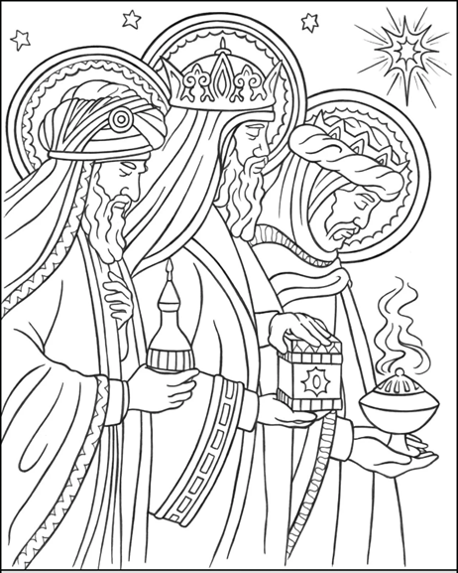
HYMN: WE THREE KINGS

We three kings of Orient are;
Bearing gifts we traverse afar,
Field and fountain, moor and mountain,
Following yonder star.

Refrain: O star of wonder, star of night,
Star with royal beauty bright,
Eastward leading, still proceeding,
Guide us to thy perfect light.

Born a King on Bethlehem's plain,
Gold I bring, to crown Him again,
King forever, ceasing never,
Over us all to reign.

Frankincense to offer have I;
Incense owns a Deity nigh..
Prayer and praising all men raising,
Worship Him, God Most High.

Myrrh is mine: its bitter perfume
Breathes a life of gathering gloom;
Sorrowing, sighing, bleeding, dying,
Sealed in the stone-cold tomb.

Glorious now, behold Him arise,
King and God and sacrifice..
"Alleluia! Alleluia!"
Earth to the heav'ns replies.
EPIPHANY – BAPTISM
“Repent and be baptized every one of you in the name of Jesus Christ.” (Acts 2:38)
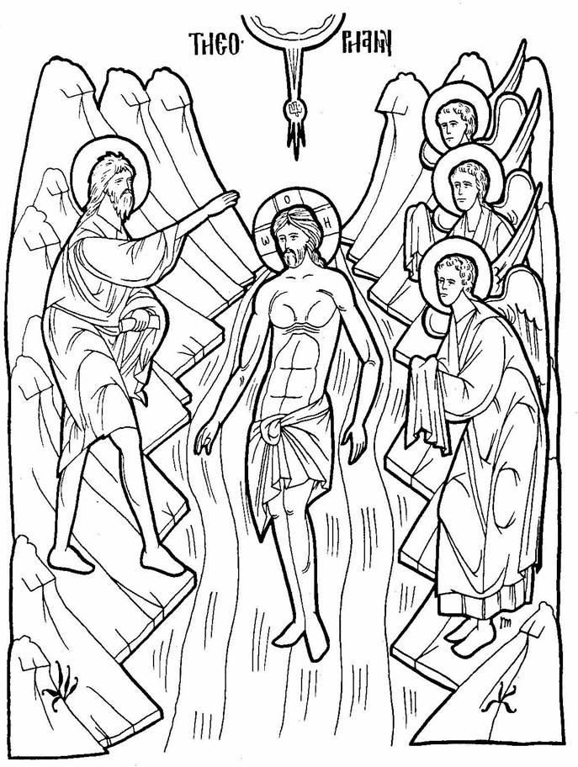
DECODE THE MESSAGE:
Hint: On an empty stomach, I fed on locusts and honey for the entire time I was living in the desert (Matthew 3:4). Who am I?
A | B | C | D | E | F | G | H | I | J | K | L | M
N | O | P | Q | R | S | T | U | V | W | X | Y | Z
J O H N T H E B A P T I S T
___ ___ ___ ___ ___ ___ ___ ___ ___ ___ ___ ___ ___ ___
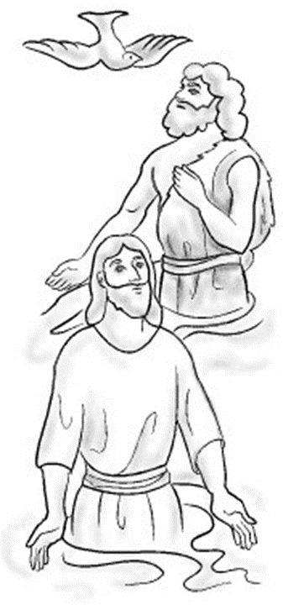
John the Baptist
Prepares the Way for Jesus - Matthew 3 (KJV)
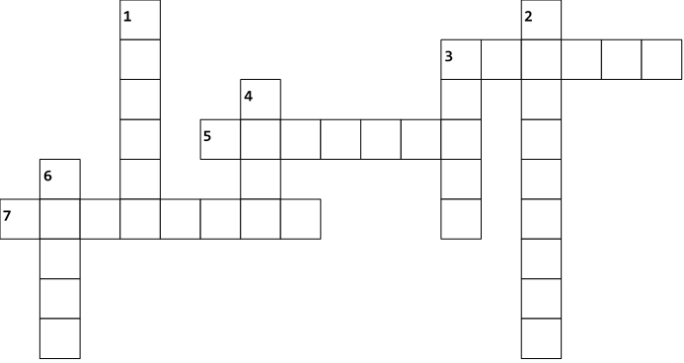
God had a special work for John the Baptist. He was to prepare the people so they could accept God's son. First, they needed to repent of their sins. The prophet Isaiah prophesied about John. Read what he said in Matthew 3:3
P

E
A
C
H
I
N
G
E

U
S
C

M
E
L
D

V
R
E
P
E
N
J O R D A N
L O C U S T S
B A P T I Z E D

Across
3. Many people confessed their sins and were baptized by John in the ________ river. (vs.6)
5. John ate ___________ and wild honey in the desert (vs.4)
7. Jesus came from Galilee to the Jordan river to be ____________ by John. (vs.13)

Down
- John's message was to ________ . (vs.2)
- John ___________ in the desert of Judea. (vs.1)
- ___________ asked John to baptize Him. (vs.13-15)
- When Jesus came out of the water John saw the Spirit of God descend like a ________ on Jesus. (vs.16)
6. John wore clothes made of _________ hair. (vs.4)

Take the letters that are circled in the crossword puzzle above and unscramble them to see what God had to say about His Son Jesus after He was baptized by John. A voice from heaven said, "This is My Beloved Son, in whom I am well
P L E A S E D
__ __ __ __ __ __ __ ." (vs.17)

Baptizing Children
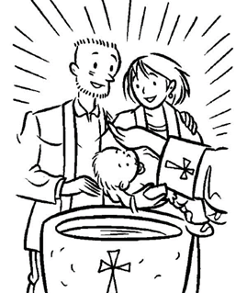
As You Grow
Written by an anonymous author

After you are baptized, you are born anew,
You shall grow in God’s love, yes, it is true.

As you grow, may our Heavenly Father guide you through,
Pouring down His blessings over you.

As you grow, may each breath that you take
Be filled with the wonder that only God can make.

As you grow, always be thankful for His blessings,
Give Him your best by always confessing

As you grow, no matter what you face,
Always live in God’s sweet Grace

As you grow, keep on trusting in the Lord
And you will be restored

As you grow, may you experience love endlessly
And may you live with Him eternally

Now it’s your turn, can you complete this sentence?
As I grow… ____________________________________________________________________________________________________________________________________________________________
BONUS: Jesus Obeys His Mother (KJV)
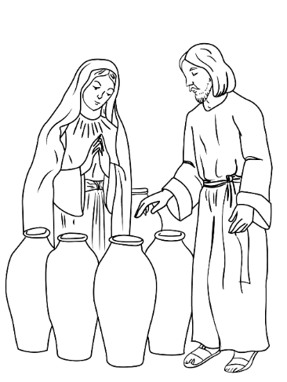

EACH WORD BELONGS TO A SENTENCE. DRAW A LINE FROM THE WORD TO THE SENTENCE IT BELONGS TO.
(ASK YOUR PARENTS TO HELP FIND THE WORDS IN THE BIBLE)
servants | - "And the ____ day there was a marriage in Cana of Galilee; and the mother of Jesus was there: "(John 2:1)
six | - "And both Jesus was called, and His disciples, to the ___."(John 2:2)
water | - "And when they wanted ___, the mother of Jesus saith unto Him, They have no ___." (John 2:3)
feast | - "Jesus saith unto her, ___, what have I to do with thee? mine hour is not yet come." (John 2:4)
third | - "His mother saith unto the ____, Whatsoever He saith unto you, do it." (John 2:5)
marriage | - "And there were set there ___ waterpots of stone, after the manner of the purifying of the Jews, containing two or three firkins apiece." (John 2:6)
governor | - "Jesus saith unto them, Fill the waterpots with ____. And they filled them up to the brim." (John 2:7)
beginning | - "And He saith unto them, Draw out now, and bear unto the governor of the ____. And they bare it." (John 2:8)
miracles | - "When the ruler of the feast had tasted the water that was made wine, and knew not whence it was: (but the servants which drew the water knew;) the _____ of the feast called the bridegroom," (John 2:9)
wine | - "And saith unto him, Every man at the ____ doth set forth good wine; and when men have well drunk, then that which is worse: but thou hast kept the good wine until now." (John 2:10)
Woman | - "This beginning of ___ did Jesus in Cana of Galilee, and manifested forth His glory; and His disciples believed on Him." (John 2:11)
Jesus Chooses 12 Disciples
Luke 5:1-11, Mark 3:13-18, Matthew 4:18-22 (KJV)
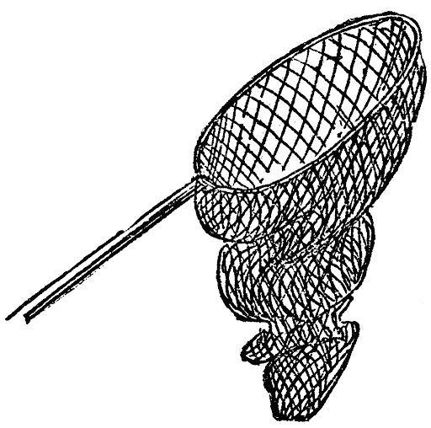
Jesus chose 12 special friends to help Him in preaching to the people. He told them in Matthew 4:18 “And He saith unto them, Follow Me, and I will make you… _ _ _ _ _ _ _ _ _ _ _ _. And they straightway left their nets and followed Him.” (Matt. 4:19-20)
OF MEN
FISHERS
In Mark 3:13-18 we read the names of the 12 disciples that He chose. Unscramble the names below and place the letters from the shapes into the matching shapes below.
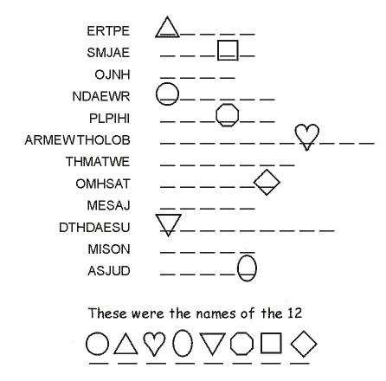
A P O S T L E S
J U D A S
S I M O N
T H A D D A E U S
J A M E S
T H O M A S
B A R T H O L O M E W
A N D R E W
M A T T H E W
P H I L I P
J O H N
J A M E S
P E T E R
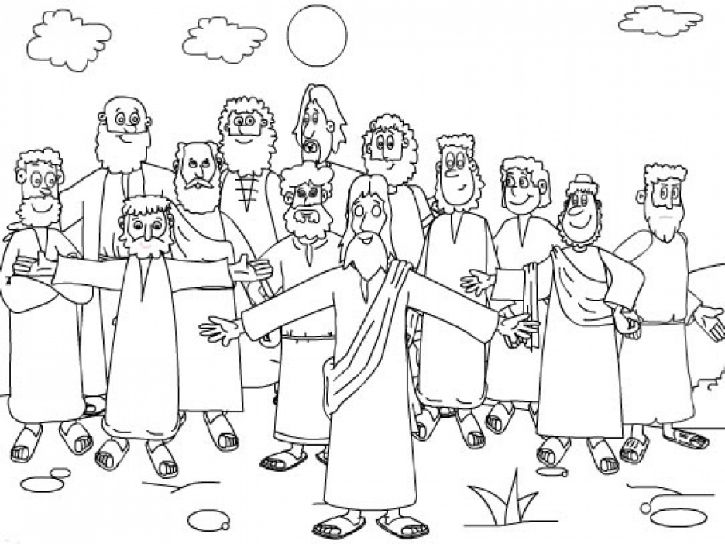
Jesus Called the Twelve Disciples
(To the tune of "Jesus loves me, this I know")
A song by Fr. Theodore (2012)

Jesus called them one by one, Peter, Andrew, James, and John,
Next came Philip, Thomas, too, Matthew and Bartholomew.
+++
Refrain:
Yes, Jesus called them, Yes, Jesus called them,
Yes, Jesus called them, The Bible tells me so.
+++
James the one they called the less, Simon, also Thaddeus,
The twelfth disciple Judas made; Jesus was by him betrayed.
+++
Matthias took Judas' place
To preach to men of every race.
+++
Paul, three preaching trips did make
And went to Rome for Jesus' sake.
+++


Jesus Cares for The Disciples
"Be of good cheer: it is I; be not afraid." (Mark 6:50)
+++
MAKE A PAPER BOAT ACTIVITY
YOU WILL NEED
PAPER

STICKY TAPE

STEP 1- Take a piece of paper and place it in front of you with the shorter side at the top. Fold the paper in half from top to bottom.

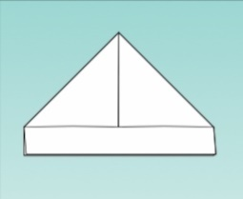

STEP 2 - Fold left to right to find the center and reopen. Bring the top two corners together to the middle, forming a point, and crease.


STEP 3- Fold the top flap at the bottom of the paper up; turn over and fold the other flap up. Fold the triangle tabs in over each other so you have a triangle.



STEP 4- Pop open the center like a hat, push the pointed sides to meet, and crease down so that you now have a square.



STEP 5- With the opening facing you, fold the top layer up to meet the other point. Turn the paper over and repeat.


STEP 6- Gently pull apart the top two points while pushing out with your fingers to form the bottom of the boat. Reinforce corners with clear tape, and also tape around the bottom to keep your boat dry. Now you're ready to launch your craft!

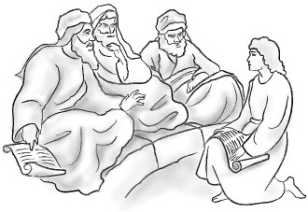
Jesus went to the Temple
Jesus as a Boy
Luke 2:40-51 (KJV)
Jesus "grew and waxed strong in spirit, filled with wisdom and the grace of God was upon Him." Luke 2:40

Jesus and his family went to Jerusalem every year for a Jewish celebration called the Feast of the Passover. When Jesus was twelve years they went once again. After they started to go back home Joseph and Mary discovered that Jesus was not with them, so they turned around and went back to Jerusalem to find him.

Color all the spaces below that have a dot in them to see where they found him.
Read Luke 2:46-47 and fill in the blanks to see what Jesus was doing when they found him.

D O C T OR S
"sitting in the midst of the _ _ _ _ _ _ _, hearing them and asking them _ _ _ _ _ _ _ _ _ . And all that heard Him were astonished at His _ _ _ _ _ _ _ _ _ _ _ _ _ and _ _ _ _ _ _ _ . “ (Luke 2:46-47)
ANSW E RS
UND E R S T AN D I NG
QU E S T I ON S

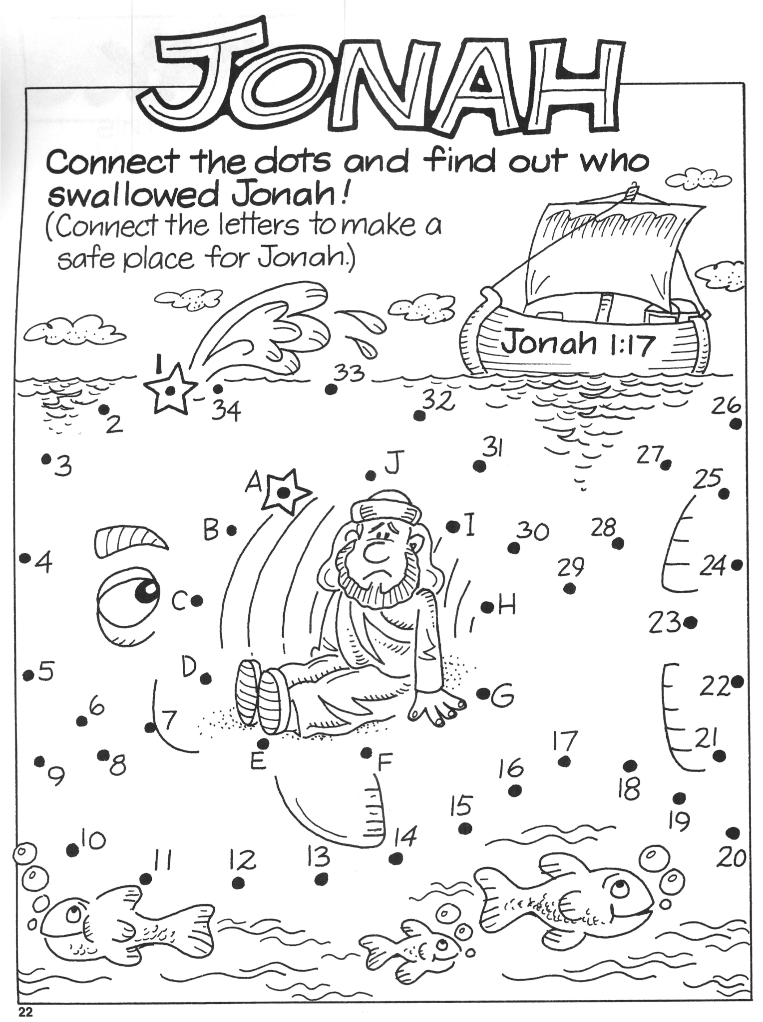
•


bible
worksheets
.org

Jonah and the Big Fish
Jonah 2
You will need:
• Thin card
• Scissors
• Blu-tack / Poster putty
• 1 split pin
• Needle
• Cotton
• Colouring pens or pencils
Jonah and the Big Fish Craft
Instructions
- Colour in Jonah and the big fish.
- Cut out the big fish.
- Cut out the circle in the centre of the fish.
- Cut out Jonah (discard the remainder of the circle).
- Make a hole in the big fish where the cross is, using scissors and leaning on the blu-tack/poster putty (for safety).
- Put a split pin in the hole.
- Thread some cotton on to the needle.
- Where the small dot on Jonah’s head is, use the needle to thread the cotton through at this point (lean on blu-tack/ poster putty).
- Form a loop with cotton and tie it in a knot, ensuring the length will suspend Jonah in the middle of the fish’s tummy.
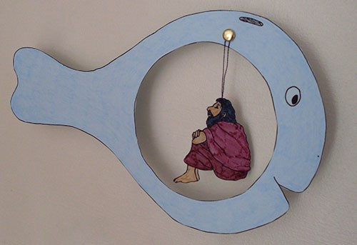

Sundays of the Lent Hymn
Refrain: Happy times do we spend
With Our Saviour during Lent,
Weeks go by as we fast and try
Living every word He said.

1- First thing we learn to keep
Spiritual works secret and deep,
We fast and offer alms and say,
To you only Lord I pray.
No one sees me except My Lord
Who grants the heavenly reward.

2- First week we learn to seek
Kingdom of God and to keep
Our eyes on Him who can
Clothe the grass of the field,
Following the birds of the air
Who can neither sow nor reap.

3- Second week is our Lord's temptation
By the devil on the mount.
Third week is the Prodigal son,
Can you tell me how he won?
And who is the real Father
There awaiting you to come?

4- Fourth week is the Samaritan Woman
On her sins did she dwell,
Six hours Jesus walked
Just to meet her at the well!!
She knew He's the living water
Everyone she ran to tell!!

5- Fifth week we learn at the people
How you made the cripple whole,
Thirty-eight years he had to tarry
Before You said his bed to carry.
Sixth week is the blind born
Whose faith in You won't be torn.

6- Seventh week is Palm Sunday
When we receive You in our hearts,
Clothes and garments we're spreading
And the colt treads on to pass!!
Son of David: Save us all,
Hosanna we won't cease to call.

Second Sunday of the Lent
Temptation in the Wilderness
(Matthew 4:1-10 KJV)
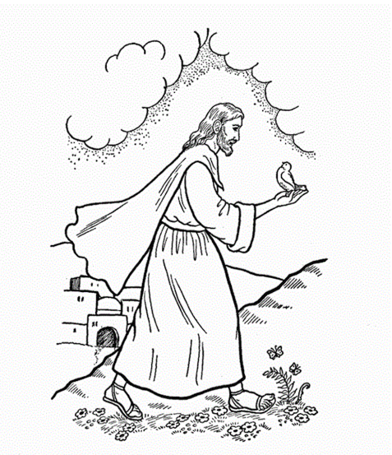
Check the correct answer:

- Jesus was led by the Spirit into the wilderness to be… (Matt. 4:1)
X
- Tempted by the devil
- Run away from the world
- To have a party
- Jesus fasted for… (Matt. 4:2)
- Eighty days and eighty nights
X
- Forty days and forty nights
- He did not fast
- The tempter came to Jesus saying: “if thou be the Son of God command that …” (Matt. 4:3)
X
- “…these stones be made bread.”
- “…these birds be made chickens.”
- “…there would be fish to eat.”
- Jesus answered the tempter saying: “Man shall not live by ____ alone, but by every word that proceedeth out of the mouth of God.” (Matt 4:4)
X
- fish
- tacos
X
- bread
- The tempter than took Jesus up to the holy city and put Him on top of the… (Matt. 4:5)
X
- Temple
- Church
- Palace

- The tempter said to Jesus “If thou be the Son of God, cast thyself down: for it is written, He shall give His angels charge concerning Thee: and in their hands they shall bear Thee up, lest at any time thou dash Thy foot against a stone.” (Matt. 4:6) But Jesus replied saying: “It is written again, Thou shalt not….” (Matt 4:7)
- “…sing at the top of thy lungs.”
X
- “…tempt the Lord thy God.”
- “…jump off the building.”
- The devil then took Jesus to a high mountain and showed Him the entire world, the devil said to Jesus: “All these things will I give thee, if thou wilt fall down and worship me.” (Matt: 4:9) Then Jesus replied saying: “Get thee hence, Satan: for it is written, Thou shalt worship…” (Matt 4:10)
- “…the Lord thy God, and Him only shalt thou serve.”
- “…Satan…”
- “…nobody.”
- The devil who was tempting Jesus then left and then someone came to comfort Jesus. (Matt. 4:11) Who was it?
- The disciples
X
- Angels
- Stranger

Third Sunday of the Lent
The Prodigal Son
Forgiveness
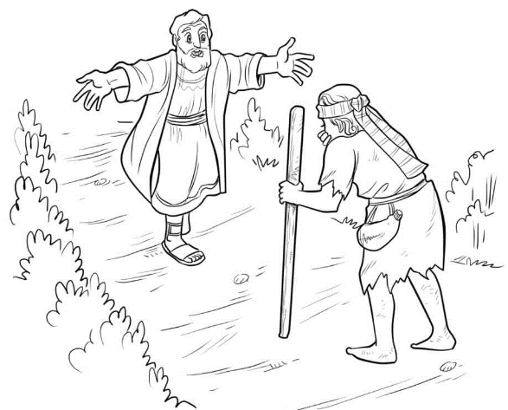
Parable of the Prodigal Son Mad Lib
Fill in the blanks with a word that you think will complete the sentence:

Jesus once told a story about a boy and his father. The boy came to his father one day and said, “Give me all the ____________that belongs to me.” Right after that, the boy gathered all his _______________ and left. The boy moved to _____________ and spent all his money on _____________ and ___________. When the boy realized he was out of money, he tried to find work at a _____________ farm. The boy was so hungry that he would’ve eaten a _____________! While the boy was at work one day, he realized that his father’s servants lived better than him. The boy knew he had done wrong, so he decided to ask his father for forgiveness. The boy __________ to his dad’s house. As soon as the father saw the boy, he ___________ to him. The boy said, “I’m sorry Father. I was wrong for taking your ____________. Please forgive me.” The father ______________ the boy and said, “Of course I’ll forgive you!”
(Action)
(Object)
(Action)
(Action)
(Bug)
(Animal)
(Event)
(Food)
(Objects – plural)
(Place)
(Object)
The Parable of the Lost Sheep
Can you find the sheep by connecting the dots?

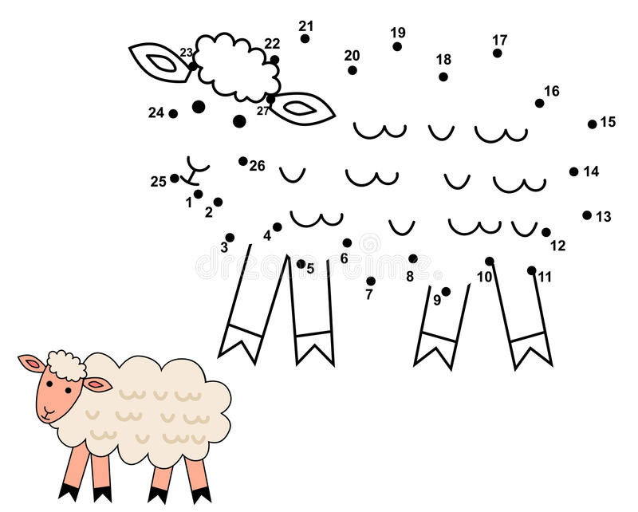
“Rejoice with Me; for I have found My sheep which was lost.” (Luke 15:6)

Fifth Sunday of the Lent
Healing the Paralytic
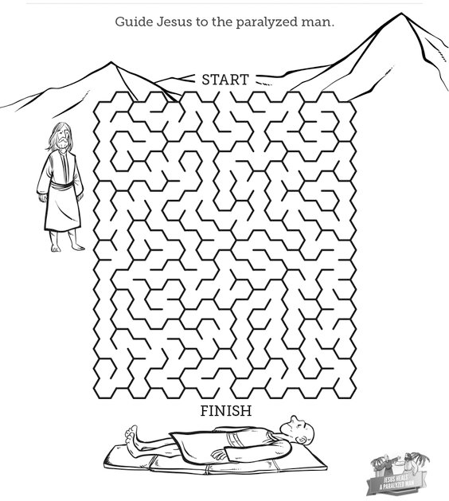

Sixth Sunday of the Lent
Jesus Heals the Blind Man
“Love one another.”
John 13:34
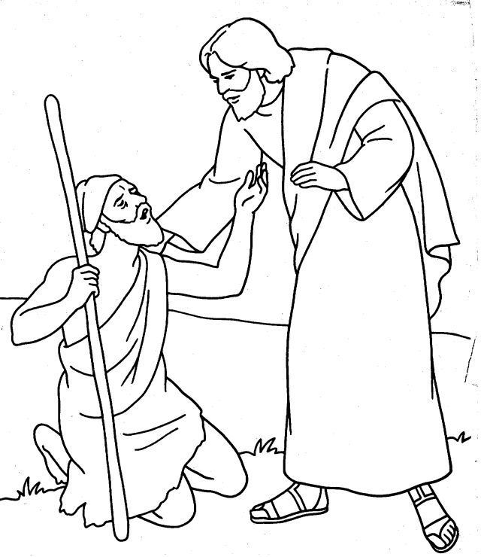
Find as many words as you can in the letters below. Go from left to right. The first one is done for you.
AT
BEG
BE
DO
IN
GOD
DOPE
AN
MAN
SEEM
IS
RAISE
PEACE
PEA
MA
SEE
PRAISE
GO
SAT
SONS
ON
ACE
ACES
SON
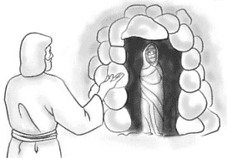
Lazarus Saturday
The Resurrection of Lazarus
John 11:1-44 (KJV)

One of Jesus's greatest miracles was the raising of his friend Lazarus from the dead. You can read about it in John 11:1-44. Mary and Martha, the sisters of Lazarus, were very disappointed that Jesus was not there when their brother died. See what Jesus said to them in verses 23 and 25.

Fill in the blanks:
R I S E
"Thy brother shall _ _ _ _ again." (John 11:23)
RE S S UR E C T I O N
L I F E
Jesus said: “I am the _ _ _ _ _ _ _ _ _ _ _ _ and the _ _ _ _." (John 11:25)
The resurrection of Lazarus was a great witness to others of God's great power and that Jesus was indeed the son of God. After this miracle many put their faith in Jesus.
Find the Words from the word list in the Wordsearch puzzle below.

LAZARUS  BETHANY  MARY  MARTHA  PERFUME | SICK  JUDEA  ASLEEP  DEAD | BELIEVE  TOMB  COMFORT BROTHER | RISE  RESURRECTION  LIFE  CHRIST | MOURN WEPT  STONE  FATHER  COME
Seventh Sunday of the Lent
Palm Sunday
“Hosanna in the highest.” (Mark 11:10)
Connect the dots to make a donkey appear,
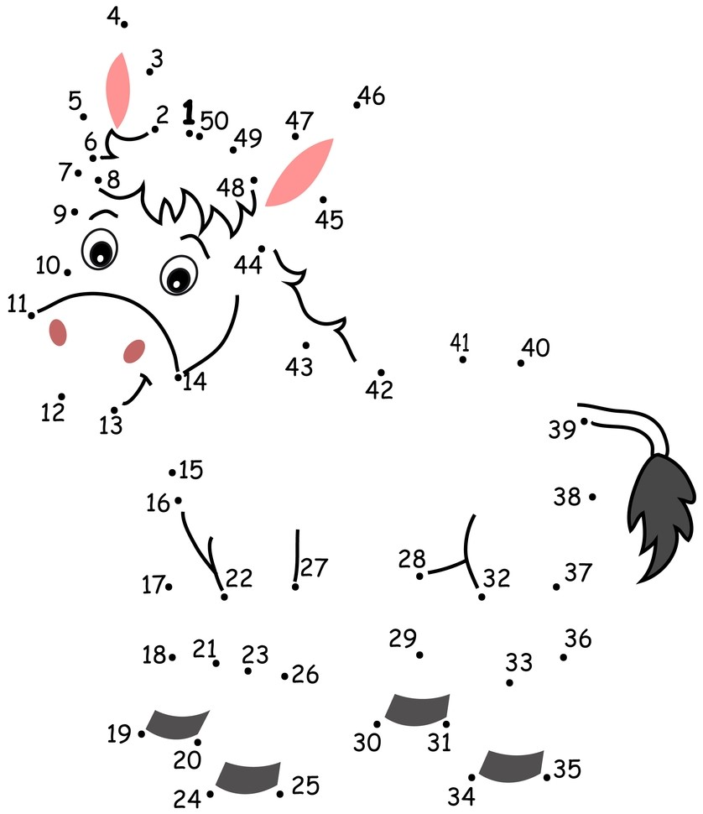
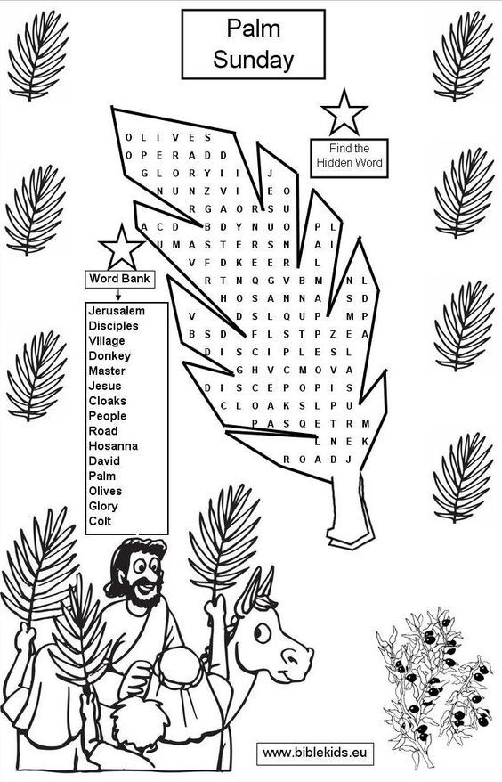
Good Friday
The Power of Jesus on the Cross
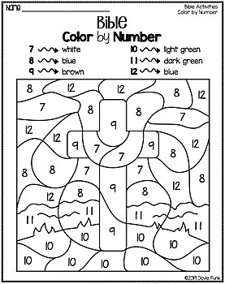
The Angel Appears to the Marys
Connect the dots to make the angel appear

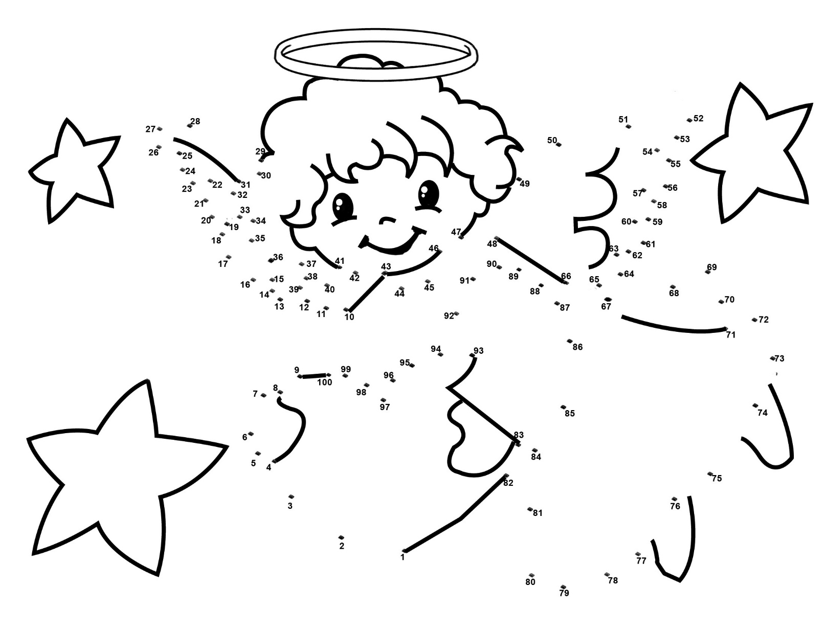
"He is not here; but is risen." (Luke 24:6)

Thomas Sunday
Thomas needed to see Jesus face-to-face for him to believe that Jesus was resurrected from the dead. Can you go through this maze and help Thomas see Jesus?
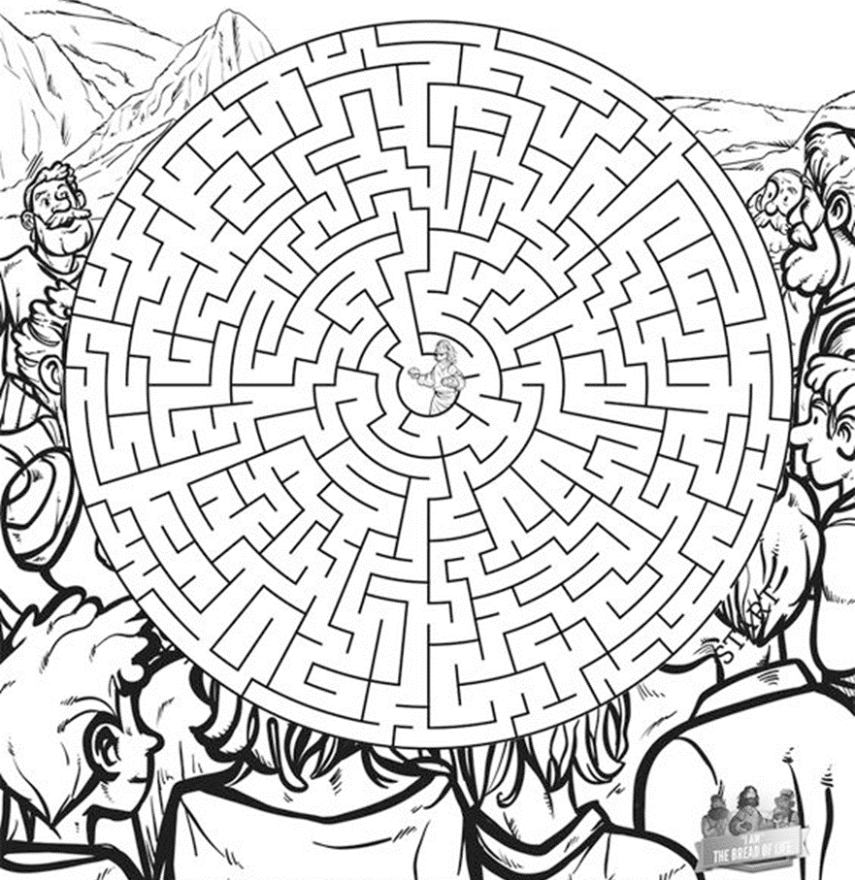
START
“Blessed are they that have not seen, and yet believed.” (John 20:29)
Daniel and the Lion’s Den
"My God hath sent His angel, and hath shut the lions' mouths." Daniel 6:22
The Lions...
Daniel was thrown into a den OF lions (Daniel 6:16). Can you name the parts OF a lion?
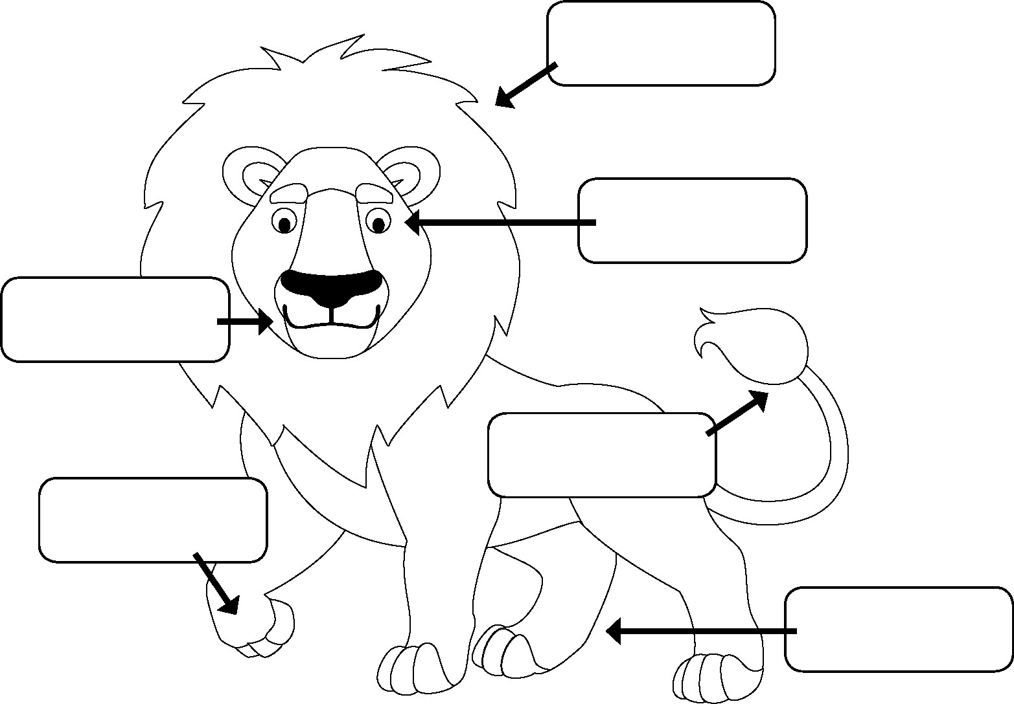
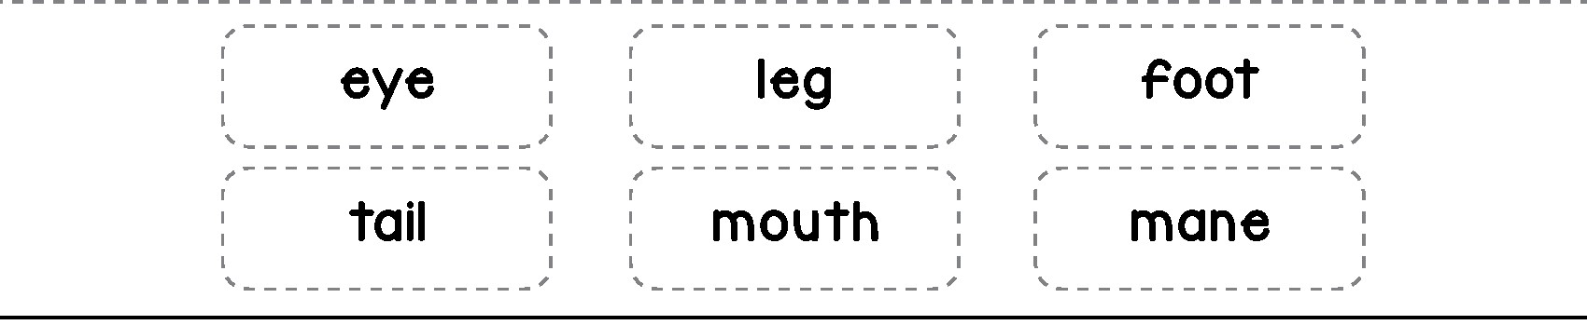

Feast of the Ascension
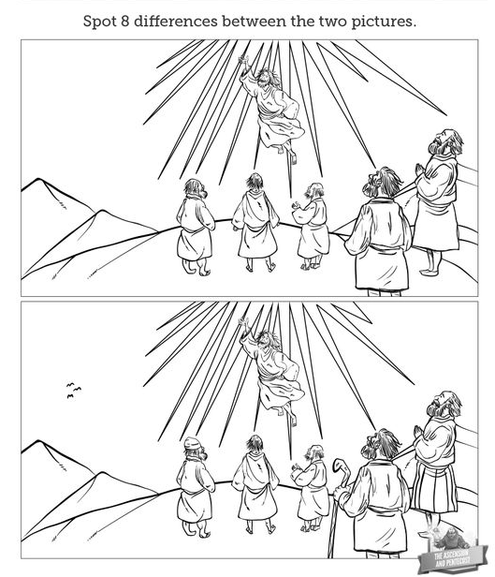
"And they worshipped Him and returned to Jerusalem with great joy." (Luke 24:52)
Feast of the Pentecost
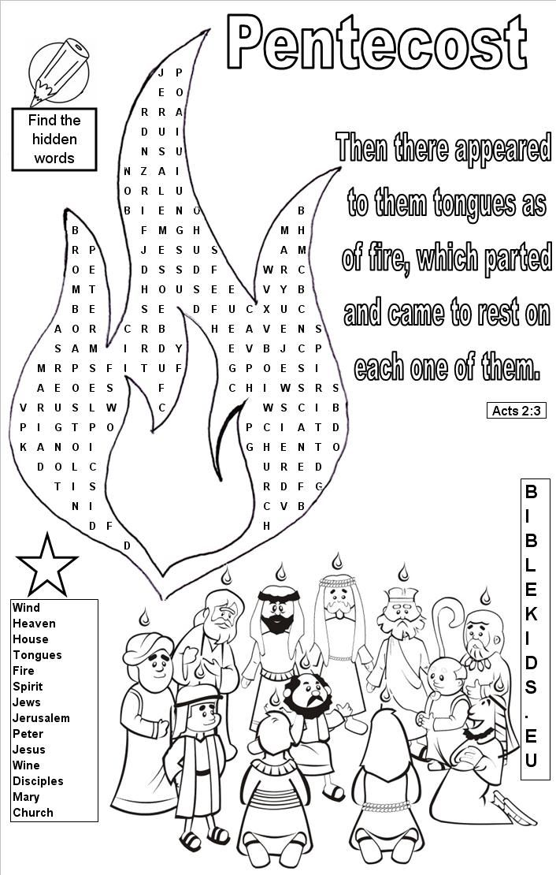

“And there appeared unto them cloven tongues like as of fire, and it sat upon each of them.” (Acts 2:3)

Apostles Feast
"The Lord thy God is with thee." (Joshua 1:9)
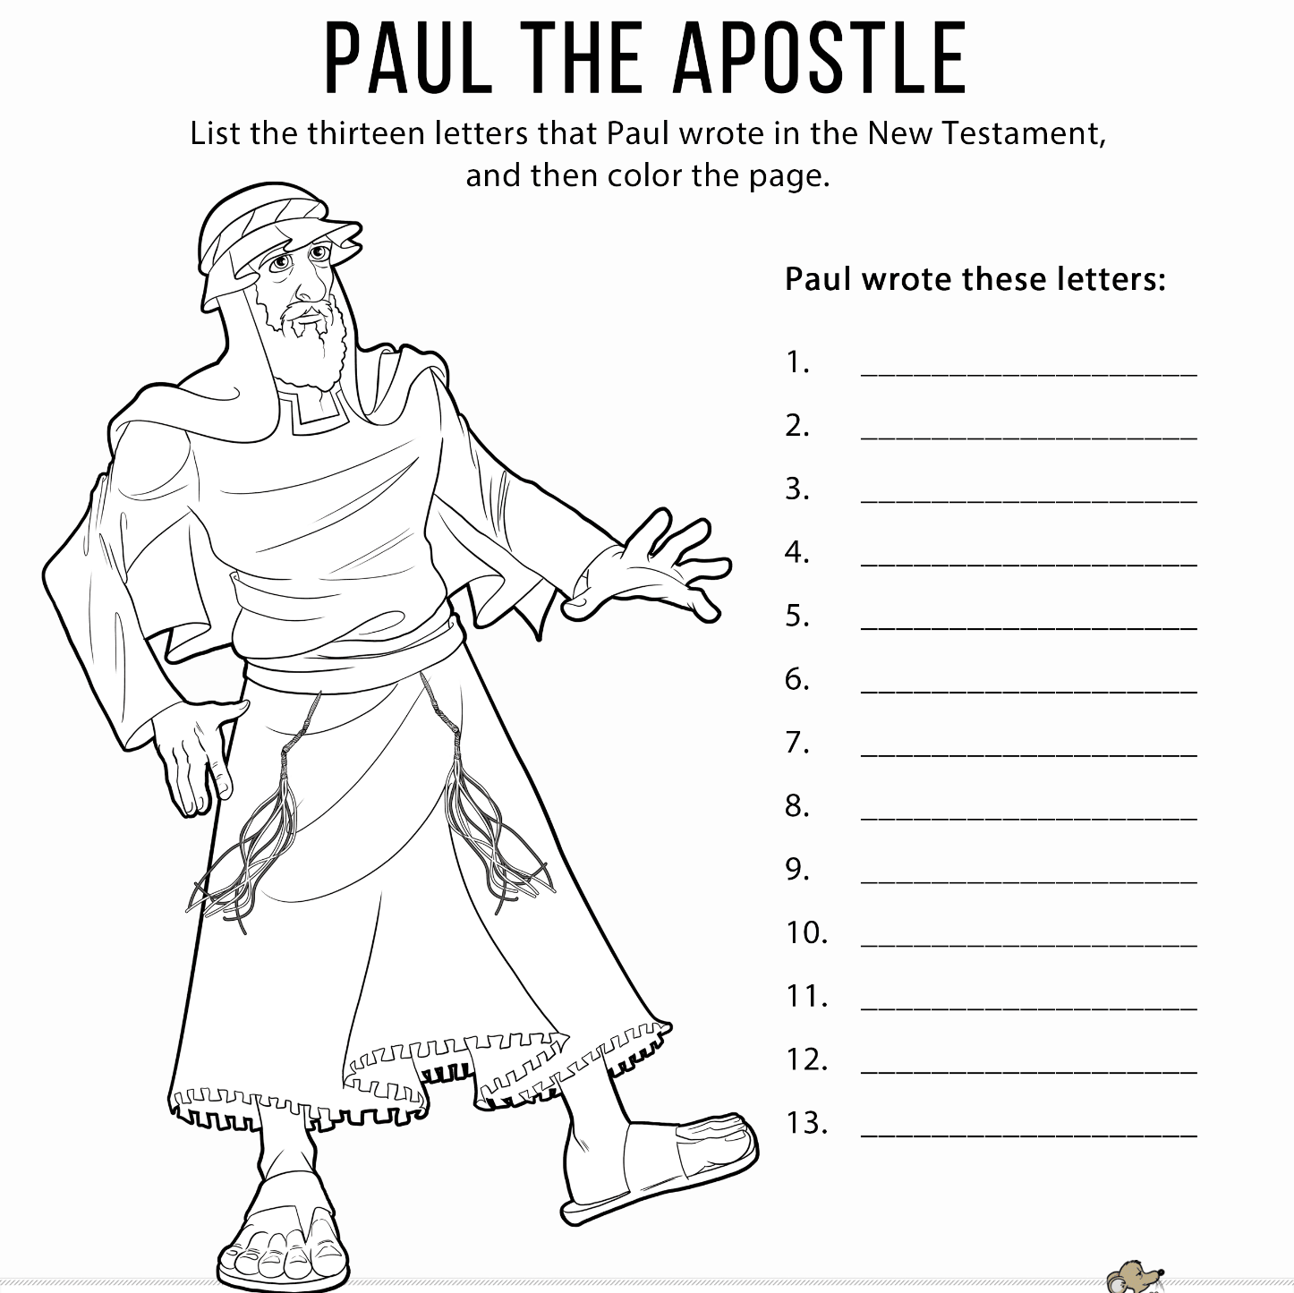
ROMANS
1 CORINTHIANS
2 CORINTHIANS
GALATIONS
EPHESIANS
PHILIPPIANS
COLLSSIANS
1 THESSALONIANS
2 THESSALONIANS
1 TIMOTHY
2 TIMOTHY
TITUS
PHILEMON

The Church Serves the Sick and the Poor
Jesus calls us to be like Him. We should serve like He served
"Give every man that asketh of thee." (Luke 6:30)

Footprints in the Sand
By Margaret Fishback Powers
One night I dreamed a dream.
I was walking along the beach with my Lord.
Across the dark sky flashed scenes from my life.
For each scene, I noticed two sets of footprints in the sand, one belonging to me and one to my Lord.

When the last scene of my life shot before me I looked back at the footprints in the sand.
There was only one set of footprints.
I realized that this was at the lowest and saddest times of my life.
This always bothered me, and I questioned the Lord about my dilemma.
“Lord, you told me when I decided to follow You, You would walk and talk with me all the way.
But I’m aware that during the most troublesome times of my life there is only one set of footprints.
I just don’t understand why, when I need You most, You leave me.”

He whispered, “My precious child, I love you and will never leave you, never, ever, during your trials and testings.
When you saw only one set of footprints, It was then that I carried you.”
― Margaret Fishback Powers

Your Footprint
"Give every man that asketh of thee." (Luke 6:30)
In the poem, Jesus carried the person when they needed help. Whenever anyone needs help, Jesus is right there by their side. We should be like Jesus and help those who are in need. Can you come up with ideas to help your family, the needy, the poor, the sick and anyone else who needs help?

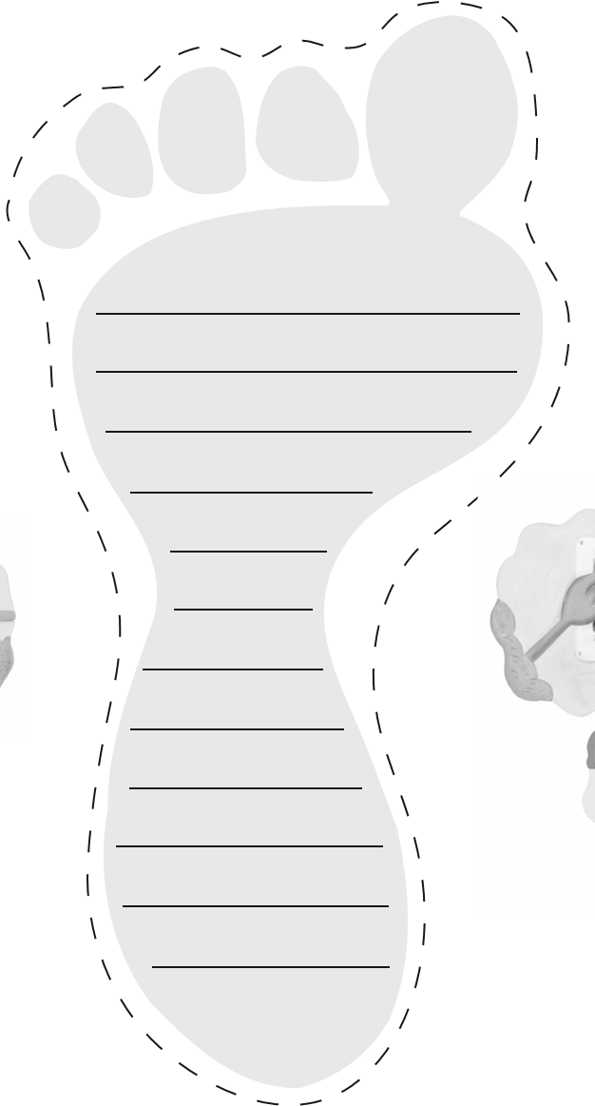

The Holy Bread- The Qurban
“Take, eat: this is my body, which is broken for you: this do in remembrance of me.” (1 Corinthians 11: 24) 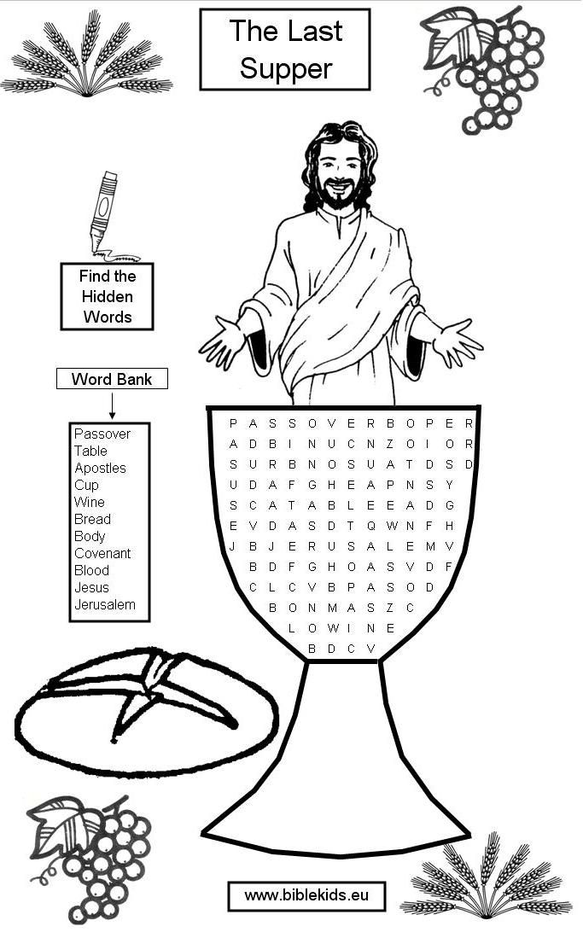
The Wise and Foolish Builders
“A wise man is strong.”
(Prov 24:5)
Find 10 differences between the pictures
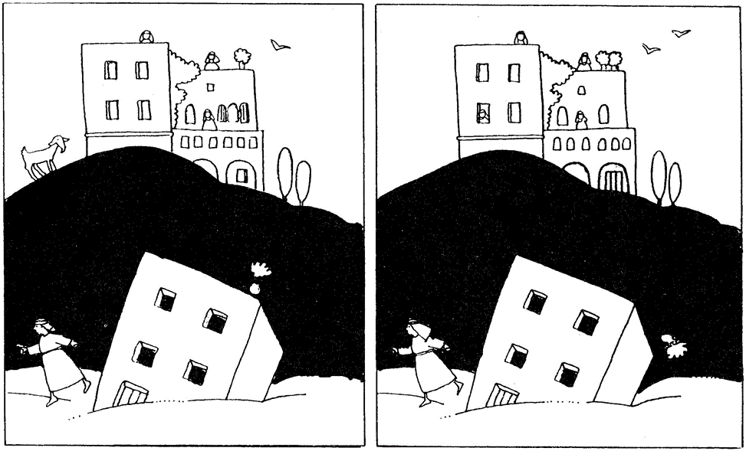
“Therefore, whosoever heareth these sayings of mine, and doeth them, I will liken him unto a wise man, which build his house upon a rock” (Matthew 7:24)

